Centennial College

**ReadCycle:**

**An Application to Market Used Books**



**Software Systems Design**

**COMP246-006**

**Professor: Sadit Zia Khan**

**Group 1, Members:**

Fatima Khalid, Chiu Wa Siu,

Manav Sharama, Nekoudari Vahideh,

Artem Kamov, Parush Madaan,

Jayraj Trivedi

PART A 2

Section I: Problem Statement 2

1.1 2

a) Problem & Need 2

i) Capabilities: 2

ii) Benefits: 3

b) Identifying the stakeholders and their roles: 3

c) Identifying the sub-systems of the application & their functional components 3

1.4) Who are the intended users of the SRS documentation. 4

1.4) Who are the intended users of the CFD Diagram. 4

SECTION II A Context Flow – Structured Modeling 5

2.1) CFD Diagram: 5

SECTION III Requirements – Functional --UML Use Case Modeling 6

3.1) Listing A Book Subsystem 6

3.1.1) Goal Use Cases 7

3.1.2) Use Case Diagram 7

3.1.3) User Stories 8

3.2) Payment Subsystem 10

3.2.1) Goal Use Cases 10

3.2.2) Use Case Diagram 10

3.2.3) User Stories: 11

3.3) Messaging subsystem 12

3.3.1) Goal Use Cases 12

3.3.2) Use Case Diagram 13

3.3.3) User Stories: 13

3.4) Order Subsystem 15

3.4.1) Goal Use Cases 15

3.4.2) Use Case Diagram 16

Section IV UML Domain Class Diagram 18

4.1) Provide a list of the classes that will contain objects of your application 18

4.2) Domain class diagram 19

SECTION V Entity Relation Diagram 20

SECTION VI System Sequence Diagrams 21

6.1) System Sequence Diagram 1 22

6.1) System Sequence Diagram 2 22

SECTION VII UML State Diagrams 22

7.1) Listing state diagram 23

7.2) Order state diagram 23

SECTION VIII Technologies 23

SECTION IX Project Management 25

9.1) Gantt Chart 25

PART B 26

SECTION I Edits to Part A 26

1.1 Added delivery and related classes to ERD and the Domain Class Diagram 26

1.2 Updated listing sequence diagram 26

1.3 Reformatted Documents 26

SECTION II Overview Model 27

2.1 Who are the intended users of the SDD document 27

2.2.1 SRS Context Flow Diagram - SFD (WHAT Diagram) 27

2.2.2 Architectural Context Diagram – ACD (HOW Diagram) 28

SECTION III Modularization 29

3.1 Partition the analysis model 29

3.1.1 Listing Subsystem 29

3.1.2 Payment Subsystem 30

3.1.3 Messaging System 31

3.1.4 Order Subsystem 31

3.2 Class Responsibility Collaboration (CRC) 32

3.2.1 Listing Subsystem CRC 33

3.2.2 Payment Subsystem CRC 34

3.2.3 Messaging Subsystem CRC 36

3.2.4 Order Subsystem CRC 37

3.3 Design Classes Diagram 38

3.3.1 Listing Subsystem 39

3.3.2 Payment Subsystem 39

3.3.3 Messaging Subsystem 40

3.3.4 Order Subsystem 41

SECTION IV Framework Model View Controller 42

4.1 MVC Diagrams 43

4.1.1 Listing Subsystems 43

4.1.2 Payment Subsystems 43

4.1.3 Messaging Subsystem 44

4.1.4 Order Subsystem 45

4.2 Full Sequence Diagrams 46

4.2.1 Sequence Diagram 1 47

4.2.2 Sequence Diagram 2 48

4.3 State Machine Diagrams 49

4.3.1 Listing State Diagram 49

4.3.2 Order State Diagram 49

SECTION V Data Layer 50

5.1 Database Schema 51

5.2 Technology List Update 51

SECTION VI Project Management 51

6.0 Updated Gantt Chart 52

PART C 52

SECTION I.0 Corrections 53

1.0.1 Updated Sequence Diagram for Messaging Subsystem 53

SECTION I Software Design Patterns 53

SECTION II Using Common Software Design Patterns 53

2.1 Listing 54

2.2 Payment 55

2.3 Messaging 57

2.4 Order 58

SECTION III UI/UX Design 60

3.1 Listing 60

3.2 Messaging 61

3.3 Order 61

3.4 Payment 62

SECTION IV High Level Component/Deployment Diagram 63

SECTION V Project Management 63

# **PART A**

# Section I: Problem Statement

## 1.1

## a) Problem & Need

The sale of second-hand books is as prevalent today as it has always been. There are not many bookstores that fulfill the needs of consumers when it comes to used books. Additionally, there are limited delivery options on other applications for consumers who are unable to pick up items in person, and this is where our app bridges the gap.

Our software solution, the ReadCycle app, allows users to sell and/or buy used books at a reasonable price and convenient delivery options. Through ReadCycle, used books will be a readily accessible commodity in a world where consumers are more inclined to purchase goods online.

### i) Capabilities:

1. Allow buyers to browse through multiple listings of used books.
2. Allow sellers to list their used books for a competitive price and have exposure to a vast number of prospective buyers.
3. Enable buyers to connect directly with sellers via messages.
4. Optional third-party delivery available for those buyers who are willing to pay the necessary fees for a more convenient way to get items delivered.

### ii) Benefits:

1. **Competitive Advantage:** Stay competitive in the book-selling market by offering a modern and convenient shopping price.
2. **Marketing Effectiveness:** Improve the effectiveness of marketing efforts through targeted campaigns and customer segmentation.
3. **Customer Engagement:** Build stronger relationships with customers through personalized recommendations and loyalty programs.

## b) Identifying the stakeholders and their roles:

**Stake holders & their roles:**

1. Buyers: Browse and purchase books
2. Sellers: List and handle book sales
3. Investors: Invest capitol for creating the ReadCycle app
4. 3rd Party Delivery Company: Deliver purchases completed by buyers who have opted for TPD

## c) Identifying the sub-systems of the application & their functional components

* User Registration and Authentication
* Book Listing
* Search and Browse
* User Profiles
* Messaging
* Order
* Payment
* Rating and Review
* Notification
* Shopping Cart and Checkout
* Inventory Management
* Geolocation and Maps
* Security
* Shipping and Delivery

1. **User Registration and Authentication**: This subsystem manages user accounts, ensuring secure registration and authentication processes to protect user data.
2. **Book Listing**: Users can create listings for the books they want to sell. This subsystem handles book information, descriptions, pricing, and images.
3. **Search and Browse**: Users should be able to search for specific books or browse through categories and genres. This subsystem is responsible for filtering and displaying relevant search results.
4. **User Profiles**: Each user has a profile displaying their listings, reviews, and contact information. This subsystem manages user profiles and their associated data.
5. **Messaging:** Facilitates communication between buyers and sellers. Users can send messages, negotiate prices, and arrange meet-ups or shipping details.
6. **Order**: Handles the processing, tracking, and status updates for orders, including order history and order confirmation.
7. **Payment:** Integrates with payment gateways to allow secure and convenient transactions for book purchases.
8. **Rating and Review**: Users can leave feedback and ratings for sellers and books. This subsystem manages and displays reviews and ratings.
9. **Notification**: Sends notifications to users for various events, such as new messages, offers, or updates on their listings.
10. **Shopping Cart and Checkout**: Allows users to add books to a shopping cart and proceed with the checkout process, including payment and shipping details.
11. **Inventory Management**: Sellers need a system to manage their listed books, marking them as sold or available, and updating book details as needed.
12. **Geolocation and Maps**: Provides location-based services for users to find nearby sellers or arrange meet-ups.
13. **Security**: Ensures data security, privacy, and protection against fraud and unauthorized access.
14. **Shipping and Delivery**: Provides options for sellers to manage shipping logistics and for buyers to track shipments.

## 1.4) Who are the intended users of the SRS documentation.

* **Development Team:** This includes the development team in charge of designing, creating, and testing the program.
* **Project Stakeholders:** Project stakeholders, who may include company owners, project managers, and investors, to comprehend the project's goals, scope, and functions.
* **UI/UX Designers:** UI/UX designers will use it to acquire insights on user interface requirements, design principles, and user interactions. This data helps them create a user-friendly and visually appealing interface.
* **Future Developers:** Future development and maintenance teams can refer to it to understand the initial design and requirements as the product changes. This allows for more informed updates and improvements.

## 1.4) Who are the intended users of the CFD Diagram.

* **Development Team:** This includes the development team in charge of designing, creating, and testing the program.
* **Project Stakeholders:** Project stakeholders, who may include company owners, project managers, and investors, to comprehend the project's goals, scope, and functions.
* **UI/UX Designers:** UI/UX designers will use it to acquire insights on user interface requirements, design principles, and user interactions. This data helps them create a user-friendly and visually appealing interface.
* **Future Developers:** Future development and maintenance teams can refer to it to understand the initial design and requirements as the product changes. This allows for more informed updates and improvements.
* Scrum Masters: Scrum Masters, in the context of Scrum (an Agile framework), may use CFDs to facilitate discussions during retrospectives and to guide the team in improving their processes

# SECTION II A Context Flow – Structured Modeling

## 2.1) CFD Diagram:

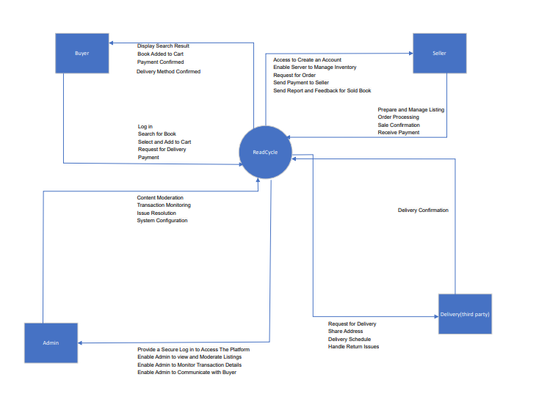

# SECTION III Requirements – Functional --UML Use Case Modeling

## 3.1) Listing A Book Subsystem

### 3.1.1) Goal Use Cases

|  |  |  |  |
| --- | --- | --- | --- |
| **FR#** | **Name (Goal Use Case)** | **Role Player** | **DESCRIPTION** |
| **FR01** | Register and sign-in | Users (Buyers/ sellers) | Users complete registration and sign on the ReadCycle app by successfully passing authentication |
| **FR02** | Create a book listing | Sellers | Registered sellers create a new listing for a used book with book title, description, condition, category, image and price required, and optional ISBN |
| **FR03** | Browse and search for items | Buyers | Allows buyers to browse listed books based on keywords or filters and location |
| **FR04** | Manage listing | Sellers | Sellers can manage their listing whilst it is active or confirm it has sold, in which case it will be deleted (and archived by the app) |
| **FR05** | Report listing | Users (Buyers/ sellers) | Allows users to report any listing that violate the ReadCycle app guidelines or have inappropriate content |

### 3.1.2) Use Case Diagram

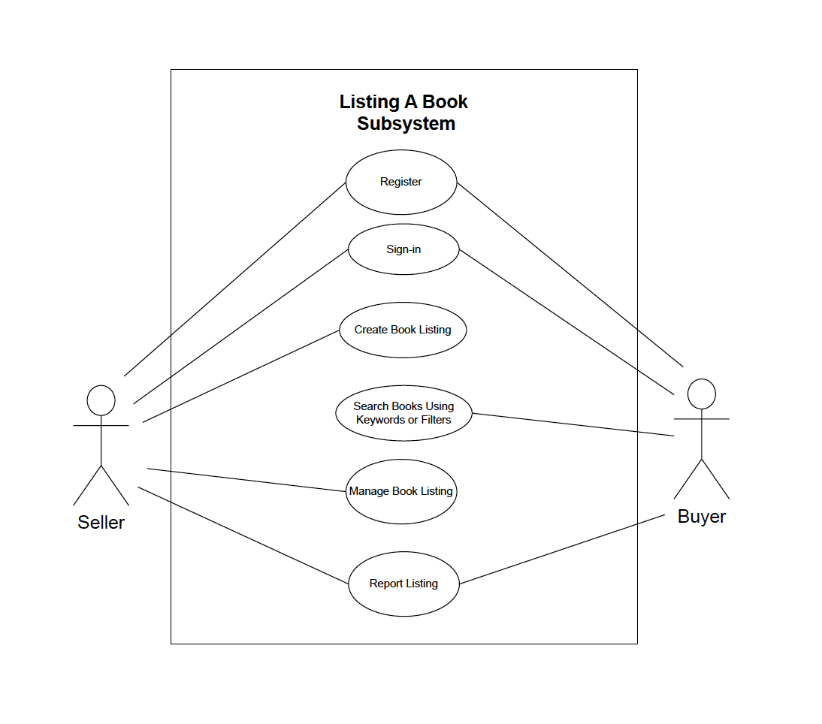

### 3.1.3) User Stories

1. As a seller I want to be able to register and login to the ReadCycle app so I can list books for sale.

Acceptance Criteria:

* + I should be able to access the registration form where I can enter my selected username, email address and password
  + After registration is completed, I should be able to login by entering my registered username and password
  + Once authenticated, as a seller, I should be directed to the homepage of the app where I can start listing books under the appropriate tab and access all the features of the app

1. As a buyer I want to be able to register and login to the ReadCycle app so I can browse through the listings and buy the book I’m looking for.

Acceptance Criteria:

* + I should be able to access the registration form where I can enter my selected username, email address and password
  + After registration is completed, I should be able to login by entering my registered username and password
  + Once logged in, I should be directed to the homepage of the app where I can start browsing for books

1. As a seller I want to be able to list used books on the ReadCycle app so I can sell them to make a profit.

Acceptance Criteria:

* + The app should have a “List a Book” feature/tab that I can access from the homepage (as all users should be able to sell/buy books)
  + I should be able to create a new listing using the book’s title, description, condition, category and price
  + I should also be able to attach an image to the listing
  + After listing, my book should be available to browse by potential buyers

1. As a buyer I want to be able to find a used book by filtering the search according to my needs so I can get exactly what I am looking for.

Acceptance Criteria:

* + I should be able to browse for a book using a search bar that allows me to enter keywords to find specific books
  + I should be able to use a filters feature on the app to narrow down search results by price range, location, etc.
  + The search results should have a sort of functionality which allows me to sort by relevance, price, etc.

1. As a seller I want to be able to update my listing or mark it sold so that I can efficiently manage all my listings.

Acceptance Criteria:

* + I should be able to access a tab for managing a listing/ editing a listing located within the listings tab
  + I should be able to update active listing details such as book title, description, price condition etc.
  + I should have an option to mark a listing as “Sold” which will cause the listing to be archived and removed from active listings

1. As a user I want to be able to report any listings that are inappropriate.

Acceptance Criteria:

* + I should have a “Report” or “Flag” button available for every listing so I can report it for inappropriate content
  + Once the button is clicked, I should be able to enter a reason for the report
  + My report should be reviewed and actioned (potentially removed) by app admin based on the report’s validity

## 3.2) Payment Subsystem

### 3.2.1) Goal Use Cases

|  |  |  |  |
| --- | --- | --- | --- |
| **FR#** | **Name (Goal Use case)** | **Role Player** | **Description** |
| **FR01** | Proceed to checkout | Buyer | The buyer initiates the checkout process when they are ready to make a purchase. |
| **FR02** | Select payment method | Buyer | The buyer selects their preferred payment method (e.g., credit card, PayPal, cash etc.) during checkout. |
| **FR03** | Enter payment info | Buyer | The buyer enters their payment details (e.g., credit card number, billing address) for processing. |
| **FR04** | Process payment | Third-party delivery / Seller | The payment gateway processes the payment transaction securely. |
| **FR05** | Generate invoice | Third-party delivery / Seller | Third-party delivery / Seller generates an invoice or receipt for the completed transaction, which may be sent to the customer. |

### 3.2.2) Use Case Diagram

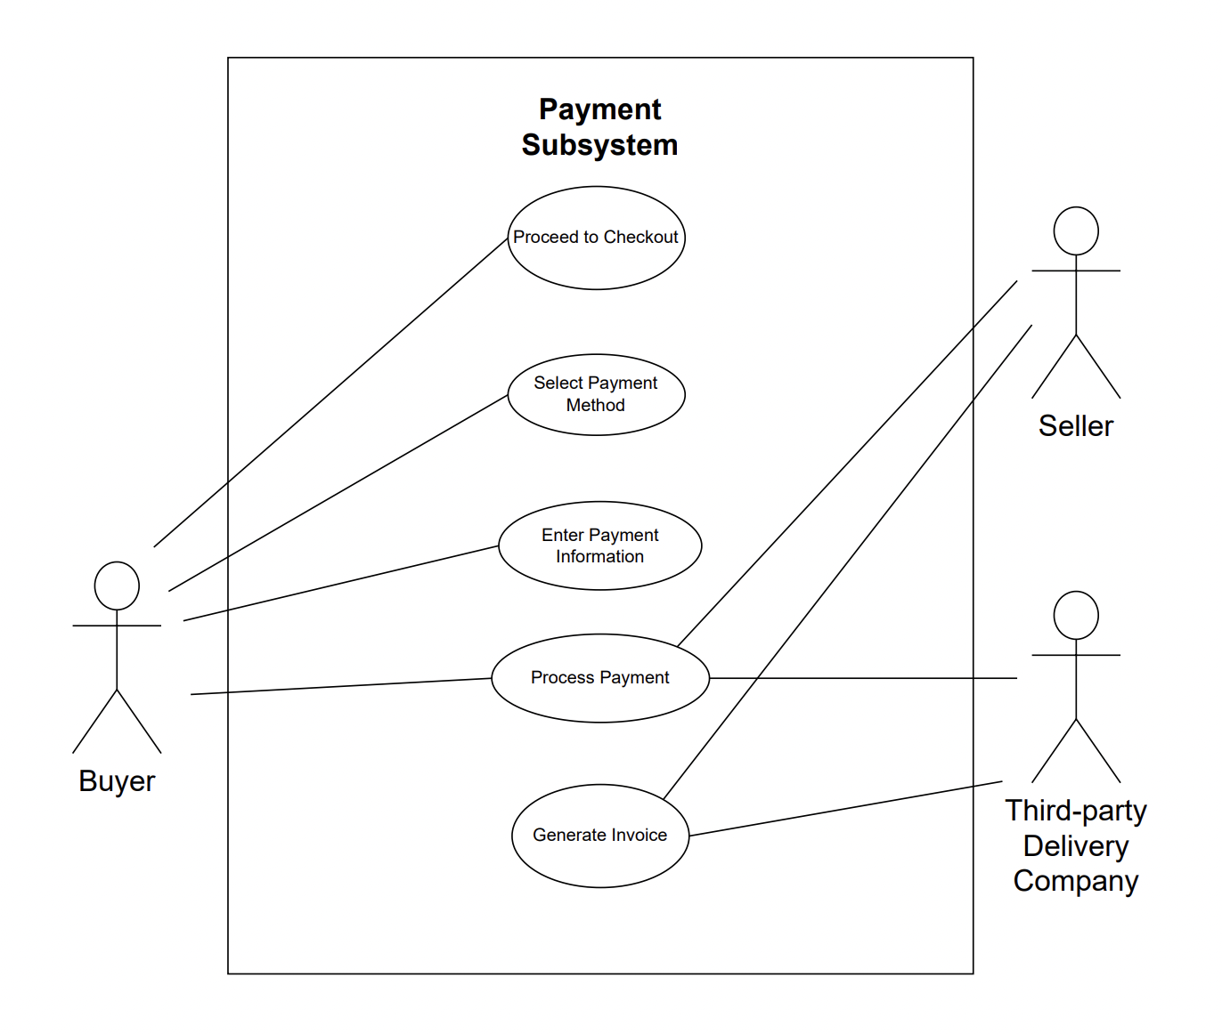

### 3.2.3) User Stories:

1. As a buyer, when I'm ready to make a purchase, I should be able to click a "Proceed to Checkout" button from the shopping cart.

Acceptance Criteria:

* + I want to review the items in my cart once more before moving to the checkout process.
  + If I'm not logged in, I should be prompted to log in or create an account.

1. As a buyer, during the checkout process, I should see a list of available payment methods (e.g., credit card, PayPal).

Acceptance Criteria:

* I want to be able to select my preferred payment method and proceed with the payment.

1. As a buyer, I want to provide my payment details securely.

Acceptance Criteria:

* + The system should prompt me to enter my credit card number, expiration date, CVV, and billing address.
  + I should receive real-time feedback on the validity of the payment information I provide.
  + After entering my payment information, I expect the payment gateway to verify and authorize my payment.
  + If the payment authorization fails, I should receive an error message with details on why the payment was declined.

1. Upon successful payment authorization, deduct the purchase amount from my account.

Acceptance Criteria:

* + If I chose delivery then third-party delivery company deduct the amount from my account.
  + If I chose to pick up then seller will give me a receipt for cash payment.

1. As a third-part delivery company / seller , they can generate an invoice or receipt for the completed transaction.

Acceptance Criteria:

* + The invoice should include details such as the book(s) purchased, the total amount paid, and the customer's information.

## 3.3) Messaging subsystem

### 3.3.1) Goal Use Cases

|  |  |  |  |
| --- | --- | --- | --- |
| **FR#** | **Name (Goal Use Case)** | **Role Player** | **DESCRIPTION** |
| **FR01** | Send Message to Seller | Buyer | Enables buyers to send messages to sellers regarding specific book listings. It facilitates communication between potential buyers and sellers for inquiries, negotiations, or additional information |
| **FR02** | Reply Sent | Users (Buyers/ sellers) | Ensures that both buyers and sellers receive timely notifications when a new message is received. It enhances responsiveness by alerting users to incoming messages. |
| **FR03** | Notification Sent | Users (Buyers/ sellers) | Allows users to reply to messages received from potential buyers or sellers. It facilitates continued communication for addressing questions, negotiating terms, and finalizing purchases. |
| **FR04** | Report/Block User | Users (Buyers/ sellers) | Allows users to take action in case of inappropriate behavior or spam from other users. It provides mechanisms to report or block problematic users, ensuring a safe and respectful community. |
| **FR0** | Send Photos in Chat | Users (Buyers/ sellers) | Enables users to share images within the chat conversation. It allows for the exchange of book-related images, enhancing the information shared during the buying process. |

### 3.3.2) Use Case Diagram

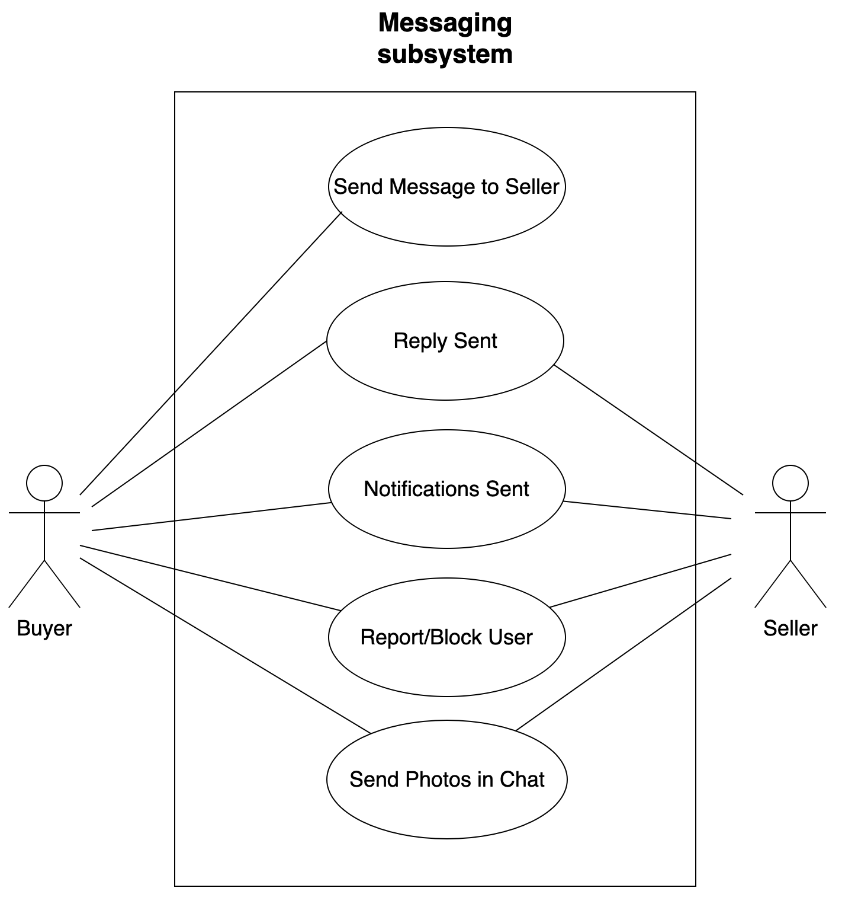

### 3.3.3) User Stories:

1. As a buyer, I would like to be able to send a message to the seller of a book listing, so that I can ask questions or negotiate the terms of the purchase.

Acceptance Criteria:

* I can locate the messaging option within the book listing details.
* I can compose a message to the seller.
* The message is sent to the seller successfully.

1. As a user (buyer or seller), I would like to be notified when a new message is received, so that I can respond promptly and efficiently manage my communications.

Acceptance Criteria:

* I can receive a real-time notification when a new message is received.
* The notification contains the name of the sender and the subject of the message.
* The notification is easily accessible from any page within the application.

1. As a user (buyer or seller), I would like to be able to reply to a message from a potential buyer or seller, so that I can address their questions or negotiate the terms of the purchase.

Acceptance Criteria:

* I can access the message from the other party.
* I can compose a reply message.
* The message is sent to the recipient successfully.

1. As a user, I would like to be able to report or block another user in case of inappropriate behavior or spam, to maintain a safe and respectful community.

Acceptance Criteria:

* I can access the profile of the user they wish to report or block.
* I can report or block the other user.
* When reporting, I can provide details about the issue.
* When blocking, I am no longer able to receive messages from the blocked user.

1. As a user, I would like to be able to send photos in the chat, so that I can share images of the book or relevant information.

Acceptance Criteria:

* I can access the option to attach a photo while composing a message.
* I can select and attach a photo from their device.
* The photo is displayed within the chat conversation for both parties.
* The photo is sent and received successfully.

## 3.4) Order Subsystem

### 3.4.1) Goal Use Cases

|  |  |  |  |
| --- | --- | --- | --- |
| **FR#** | **Name (Goal Use case)** | **Role Player** | **Description** |
| **FR01** | Create Order | All users | Buyers should be able to place an order if they have made a purchase. |
| **FR02** | Cancel Order | All users | Buyers and Sellers should be able to cancel an ongoing order if they no longer want to proceed with the orders. |
| **FR03** | Update Order | All users | Sellers and third-party delivery company should be able to update order status as the order proceeds. |
| **FR04** | Check Order status | All users | Users should be able to check current progress of the orders. |
| **FR05** | Get All Orders | All users | Users should be able to get all their orders by status, or other criteria. |

### 3.4.2) Use Case Diagram

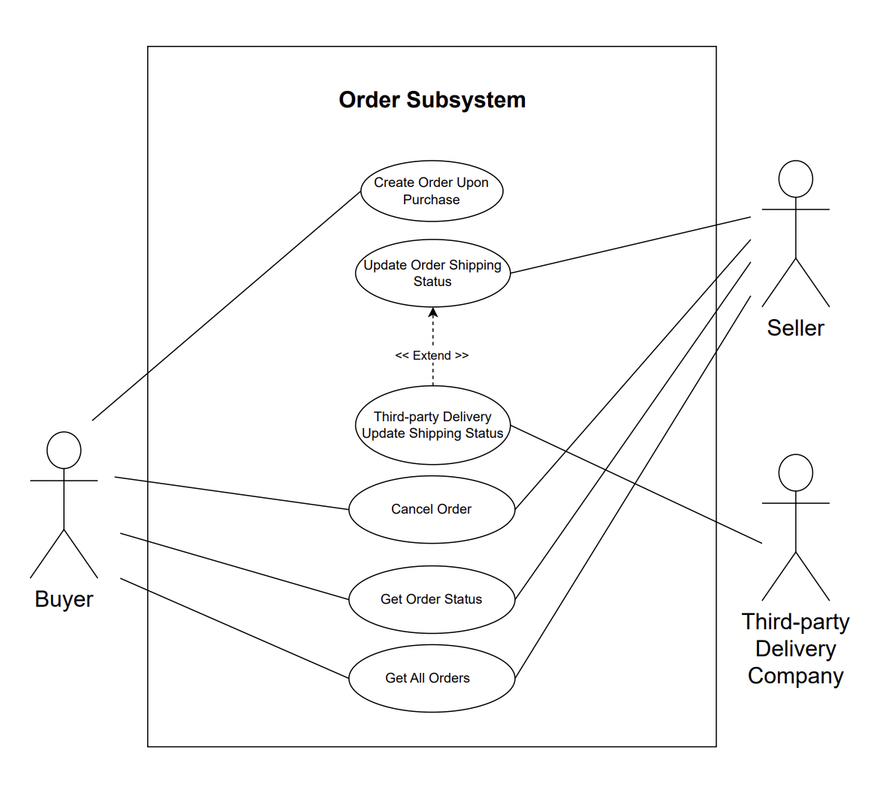3.4.3) User Stories:

1. As a buyer, I want to be able to create an order so that I could make a purchase on the items I want.

Acceptance Criteria:

* + When I have completed the payment for a purchase, I should be able to create a new order of it.
  + I should receive an email confirmation for my new order.
  + I should be able to see my new order at the order page.

1. As a Seller, I want to be able to update the order status as I proceed with an order so that the counter party could know the progress of the order.

Acceptance Criteria:

* When I have completed the delivery of the order, I should be able to mark the order as complete.
* Buyer should receive an email if the order status is changed.
* I should be able to see the status is updated at order page.

1. As a Seller, I should be able to cancel an order if there is missing information of the buyer or for any reason that the order cannot be proceeded so that the item can be available to other people.

Acceptance Criteria:

* + Sellers should be able to cancel an ongoing order and are required to provide a reason for this action.
  + Buyer should receive an email if the order is cancelled.
  + The order should be shown as cancelled at order page.

1. As a Buyer, I should be able to cancel an order if the order is not yet processed within the 14 days so that I can get a refund and the item can be returned to the market.

Acceptance Criteria:

* I should be able to cancel an order if it is not yet processed.
* I should not be able to cancel an order if it is already shipped.
* Seller should receive an email notification if the order is cancelled.
* The order should be shown as cancelled at order page.
* The item should be available in the marketplace again.

1. As a User, I should be able to check the order status of my orders so that I could know the current progress of the order.

Acceptance Criteria:

* I should be able to view the latest order status of my orders at order page.
* I should not be able to view the order status of others’ orders.

1. As a User, I should be able to get all my orders by order status or other criteria to view my orders so that I know how many orders I have.

Acceptance Criteria:

* I should be able to get my orders by order status, by time period, by order type(selling/buying) at order page.
* The order information should be latest.
* I should not be able to view order of others.

1. As a Third-party delivery company, I should be able to update the order status after I completed the delivery so that the Buyer know the order is completed.

Acceptance Criteria:

* An order with third-party delivery service should be marked as completed after the shipment has been delivered.
* An order without third-party delivery service should not be able to be updated by third-party delivery company.
* After the update, the order status should be updated at order page.

# Section IV UML Domain Class Diagram

## 4.1) Provide a list of the classes that will contain objects of your application

* *user(buyer)*
* *seller*
* *rating*
* *homePage*
* *bookListing*
* *invoice*
* *favourite*
* *messages*
* *paymentDetails*
* *pricing*
* *shipping*
* *payment*
* *3rdPartyDelivery*
* *notifications*

## 4.2) Domain class diagram

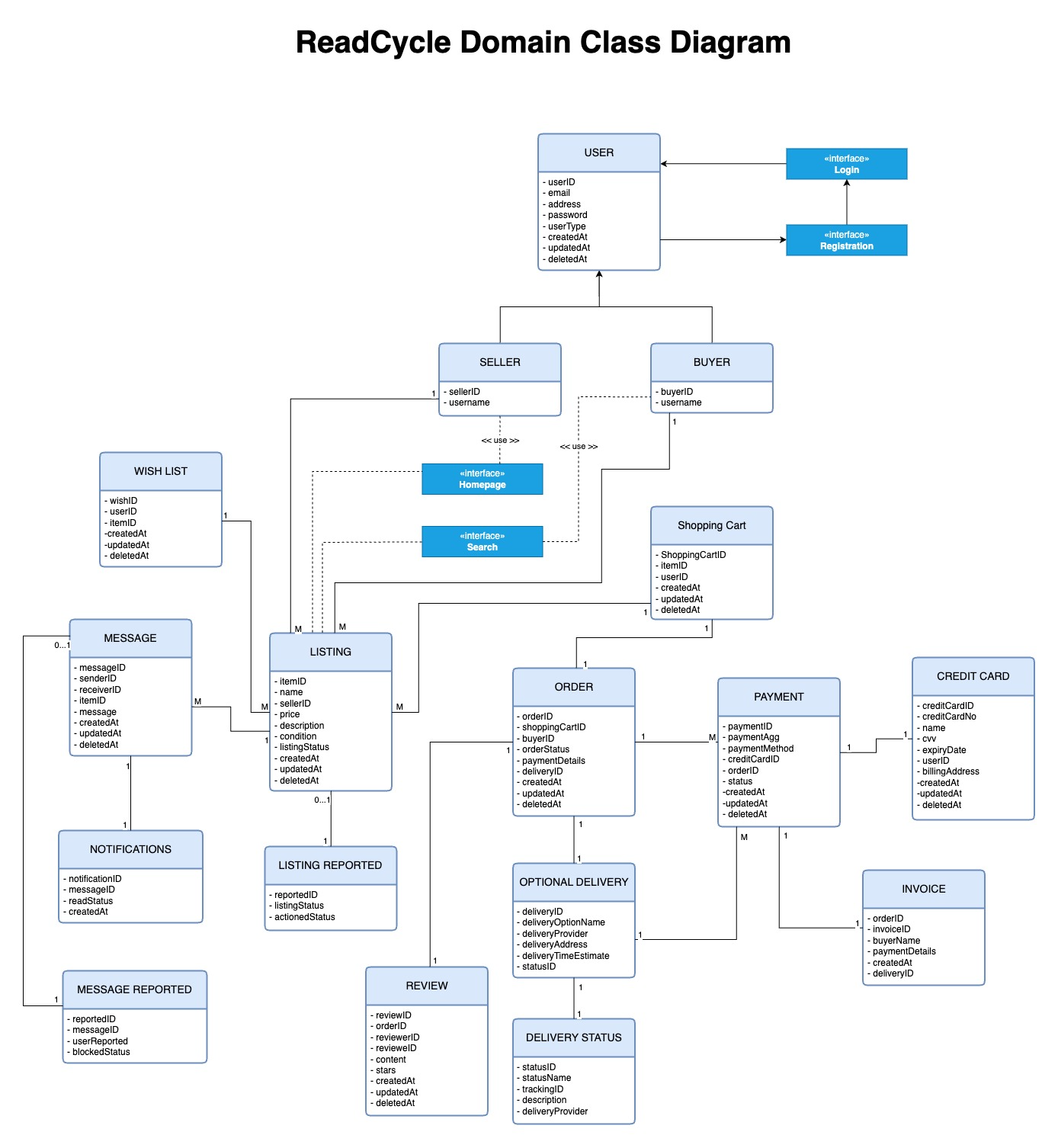

# SECTION V Entity Relation Diagram

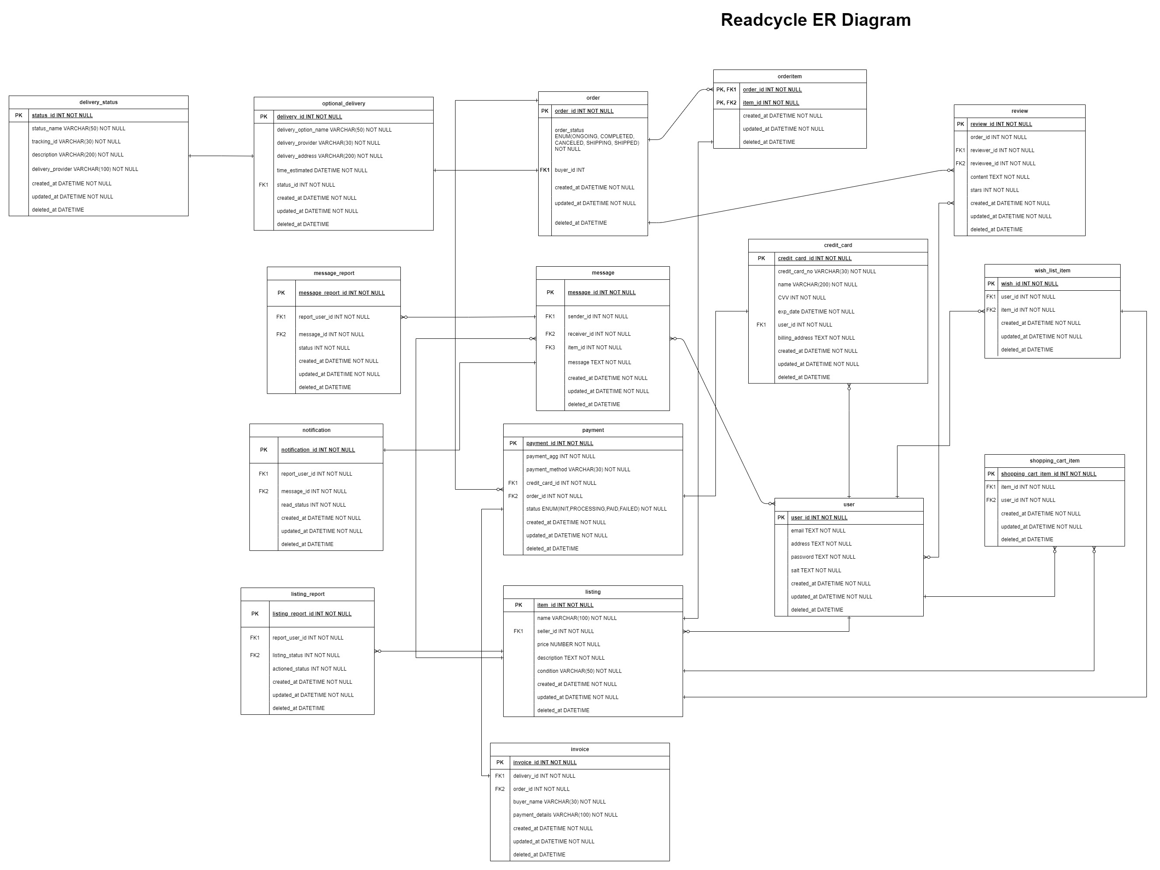

# SECTION VI System Sequence Diagrams

## 6.1) System Sequence Diagram 1

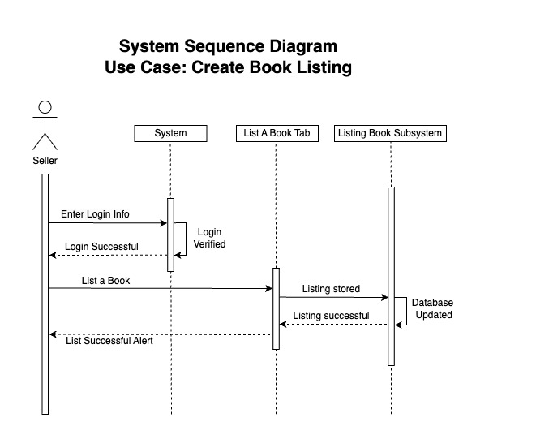

## 6.1) System Sequence Diagram 2

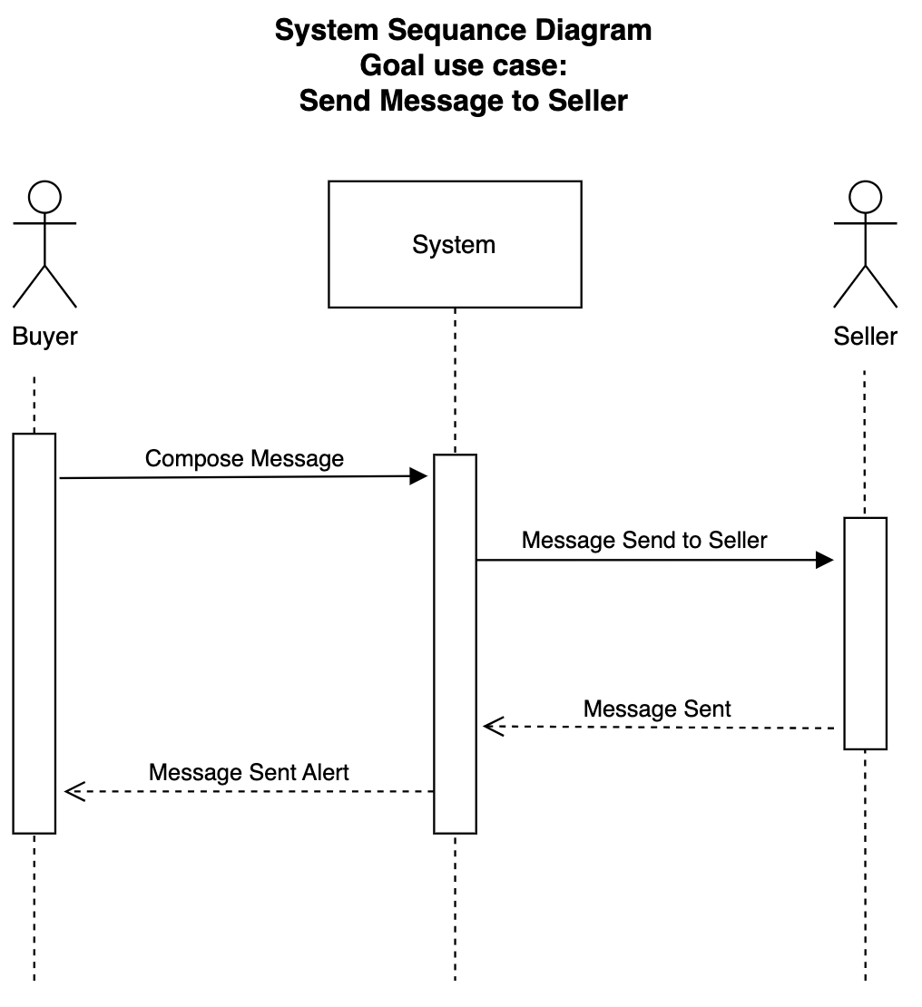

# SECTION VII UML State Diagrams

## 7.1) Listing state diagram

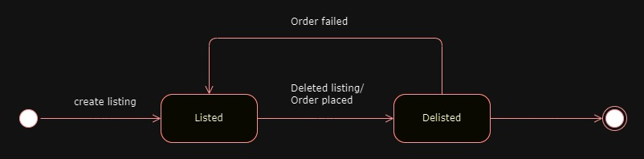

## 7.2) Order state diagram

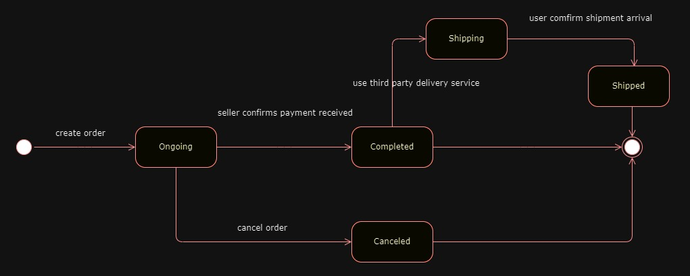

# SECTION VIII Technologies

* **Client side (Front-end – GUI):** React Native
* **Business Logic (Middle layer – Class methods etc.):** Node.js, Express.js (Server-side Logic), Firebase Authentication, (Authentication and Authorization), Built-in Mobile APIs, Elasticsearch (Search and Recommendation Engines), Stripe (Payment Integration)
* **Data side:** MongoDB

# SECTION IX Project Management

## 9.1) Gantt Chart

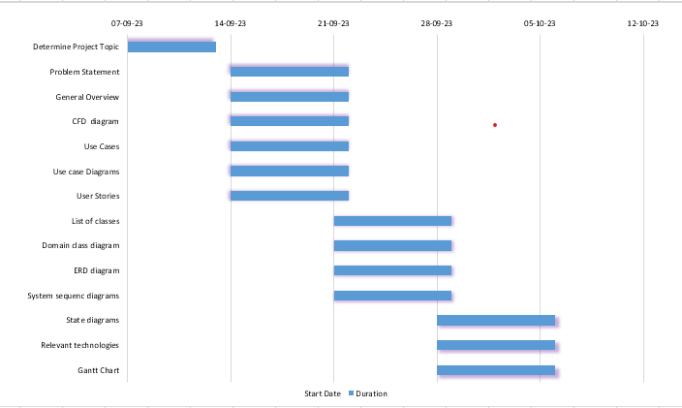

# **PART B**

# SECTION I Edits to Part A

## 1.1 Added delivery and related classes to ERD and the Domain Class Diagram

* Revised ERD and Domain Class Diagram to add Optional Delivery, Delivery Status and Invoice classes

## 1.2 Updated listing sequence diagram

* Renamed database to listing book subsystem as per simplification requirements

## 1.3 Reformatted Documents

* Adjusted document so that each new section begins on a new page

# SECTION II Overview Model

## 2.1 Who are the intended users of the SDD document

* **Development Team:** This includes the development team in charge of designing, creating, and testing the program.
* **Project Stakeholders:** Project stakeholders, who may include company owners, project managers, and investors, to comprehend the project's goals, scope, and functions.
* **UI/UX Designers:** UI/UX designers will use it to acquire insights on user interface requirements, design principles, and user interactions. This data helps them create a user-friendly and visually appealing interface.
* **Future Developers:** Future development and maintenance teams can refer to it to understand the initial design and requirements as the product changes. This allows for more informed updates and improvements.

## 2.2.1 SRS Context Flow Diagram - SFD (WHAT Diagram)



## 2.2.2 Architectural Context Diagram – ACD (HOW Diagram)

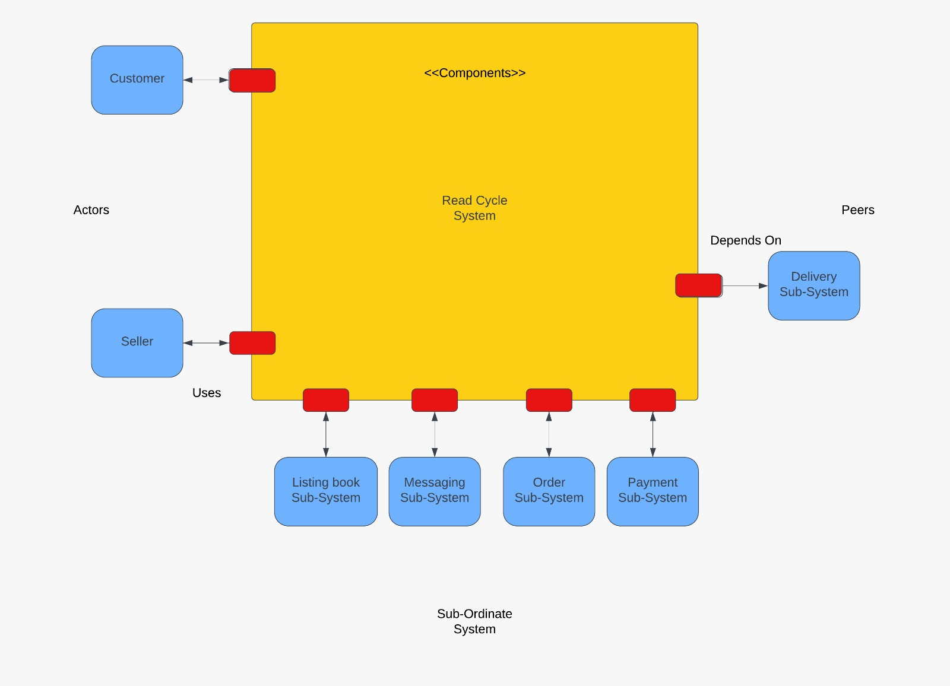

# SECTION III Modularization

## 3.1 Partition the analysis model

### 3.1.1 Listing Subsystem

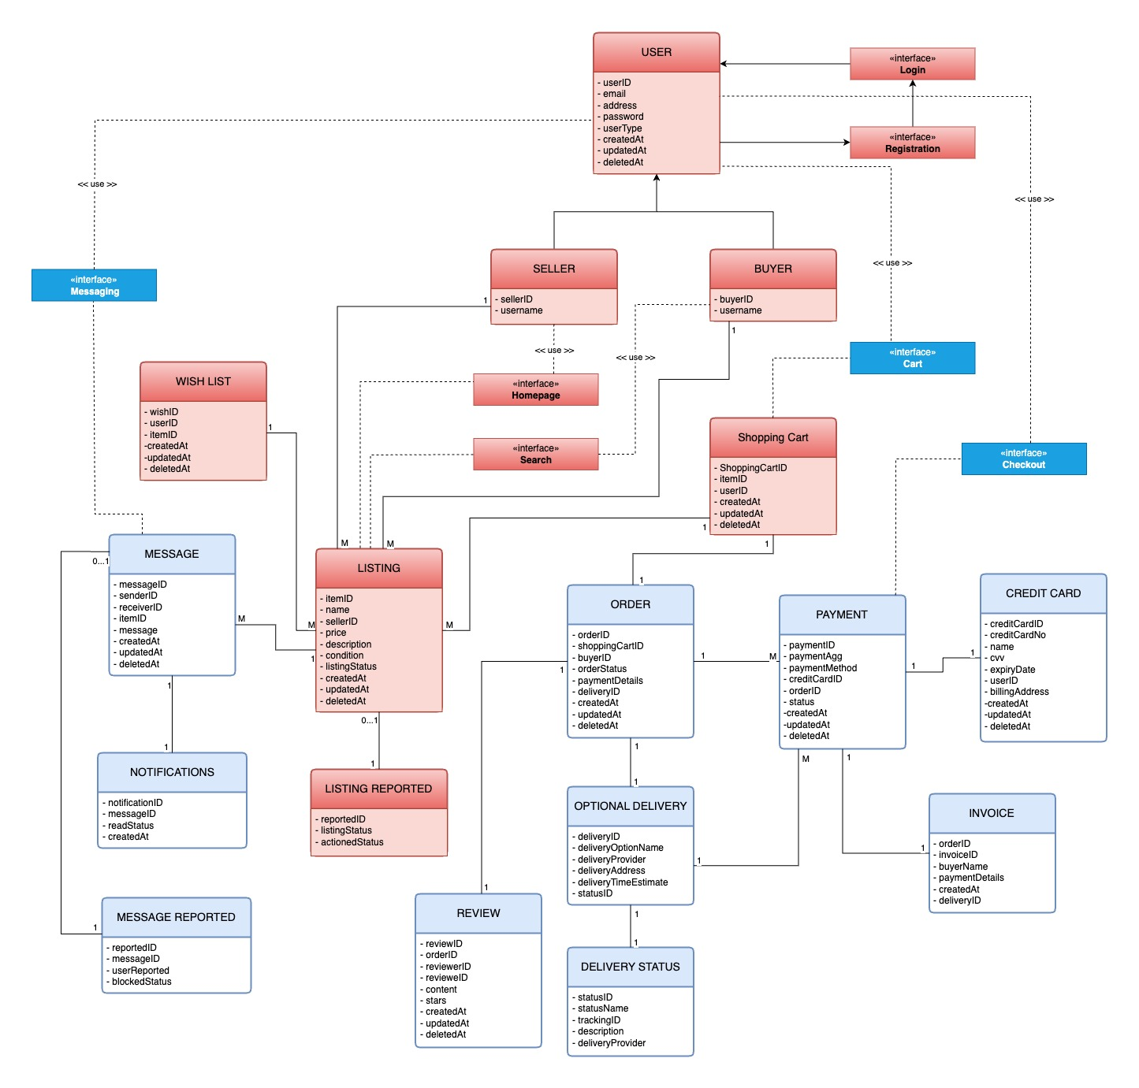

### 3.1.2 Payment Subsystem

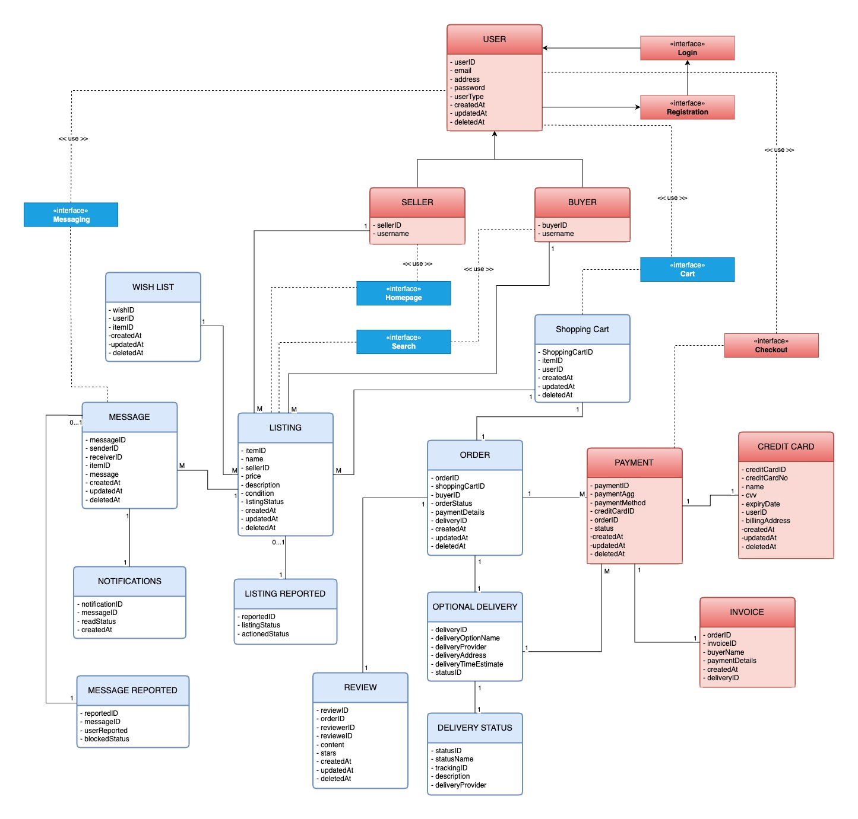

### 3.1.3 Messaging System

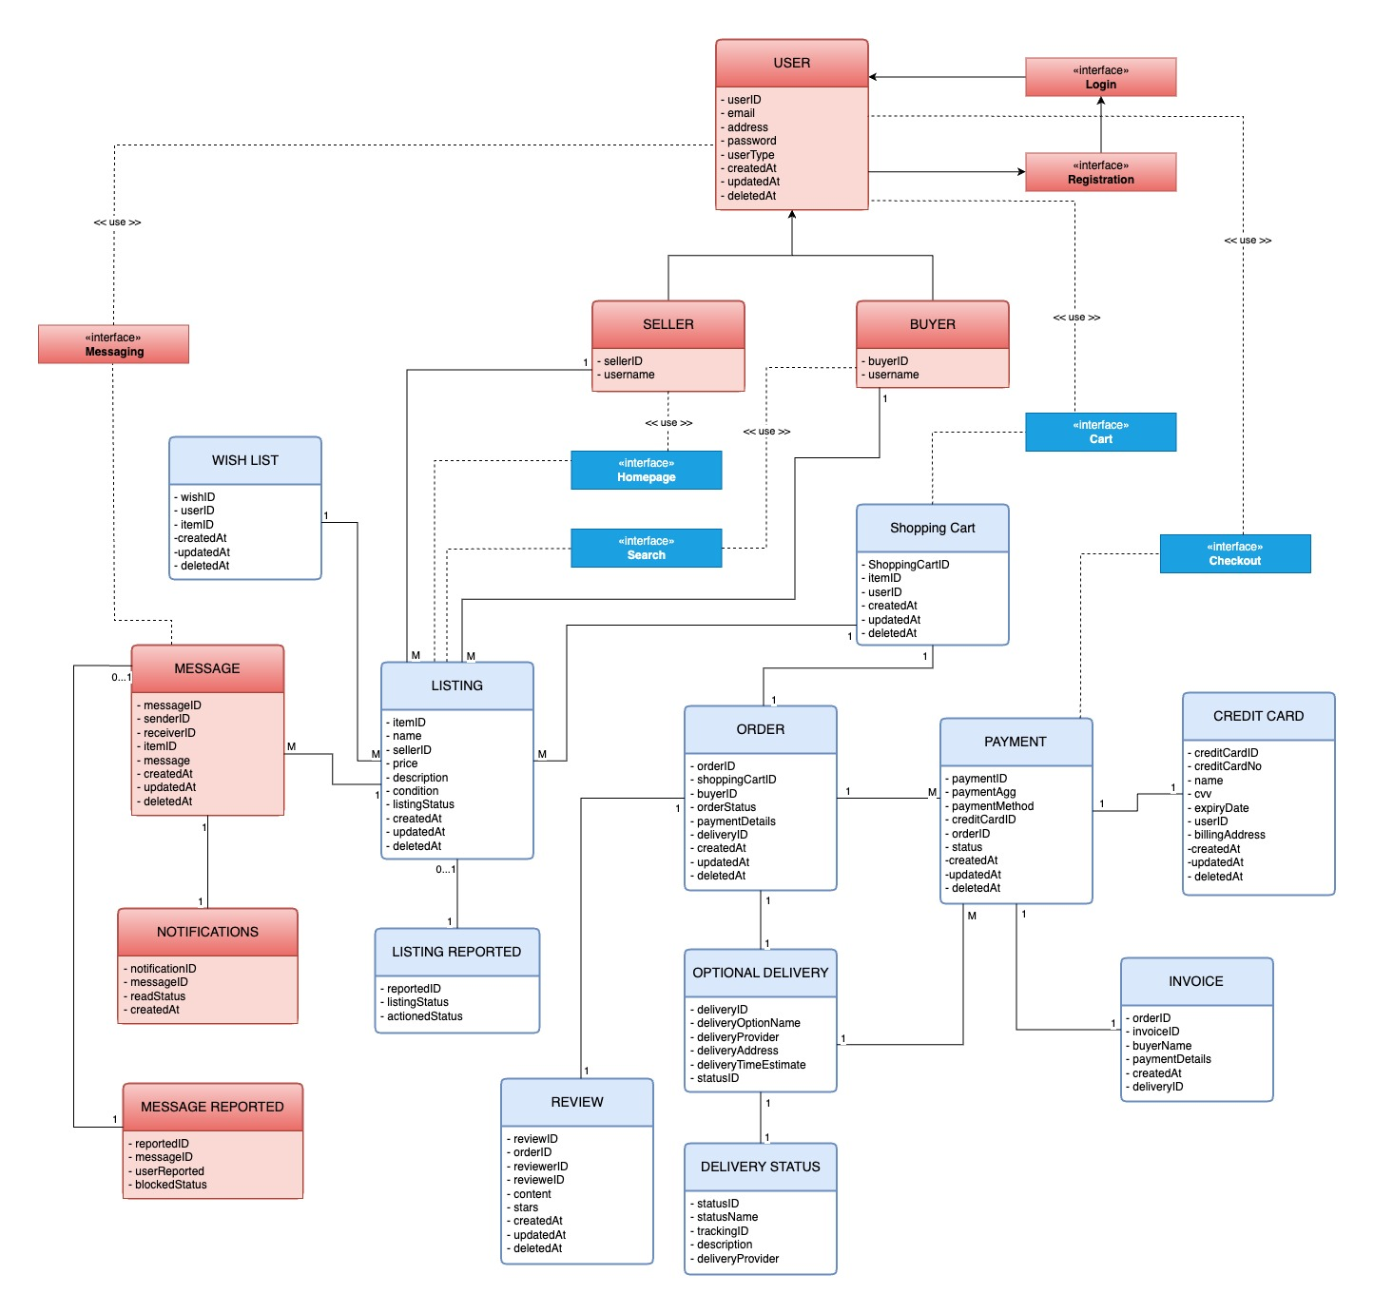

### 3.1.4 Order Subsystem

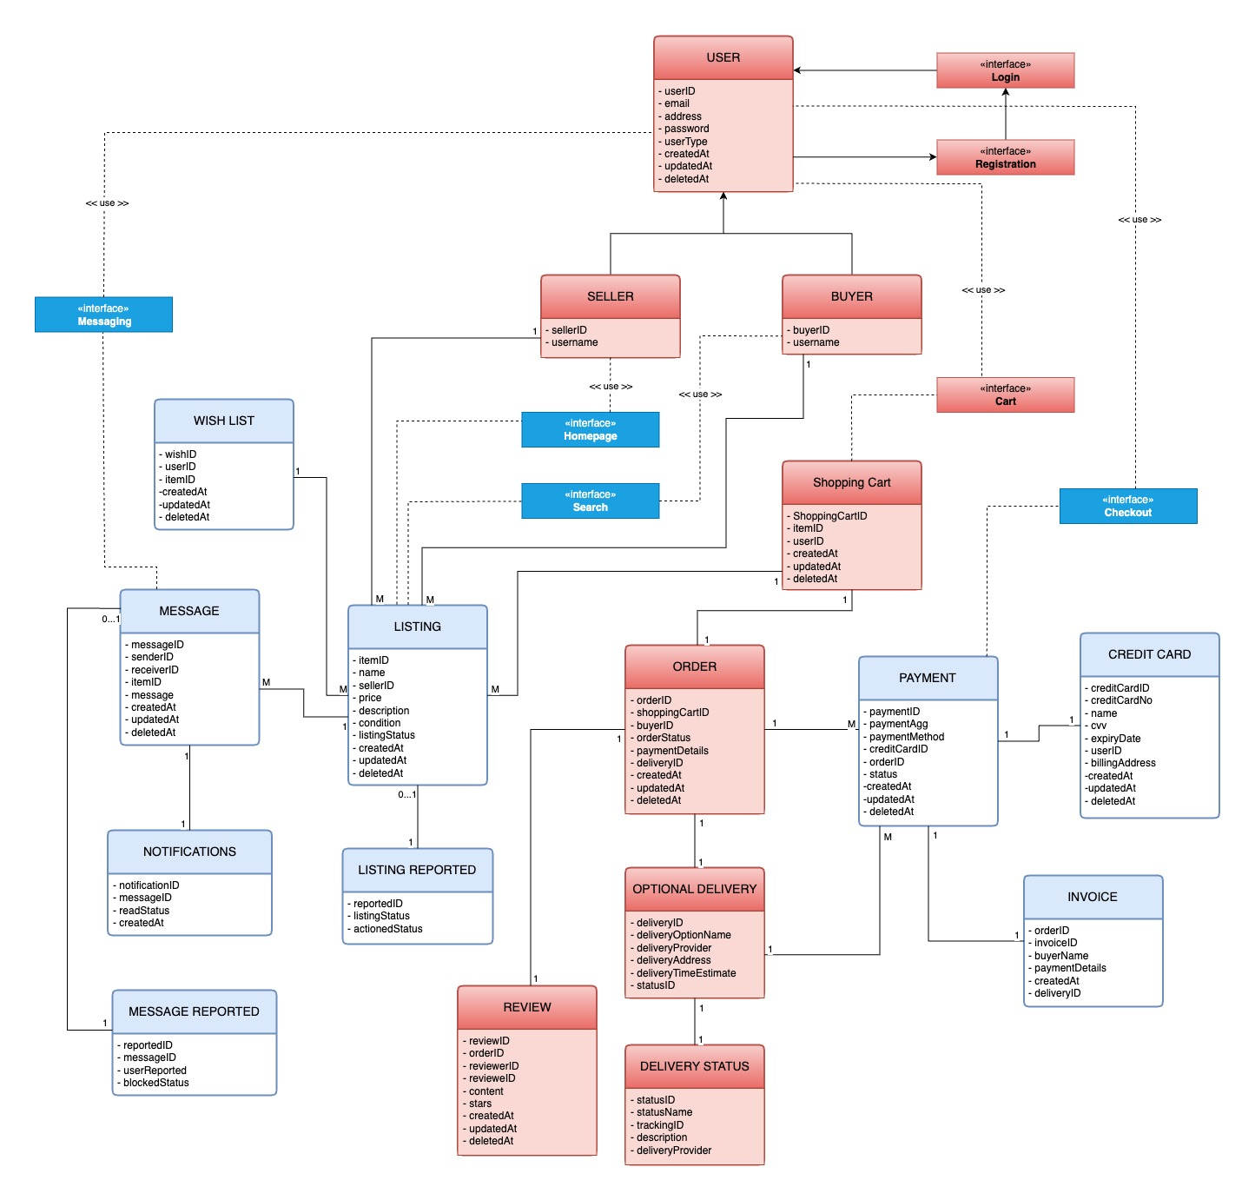

## 3.2 Class Responsibility Collaboration (CRC)

### 3.2.1 Listing Subsystem CRC

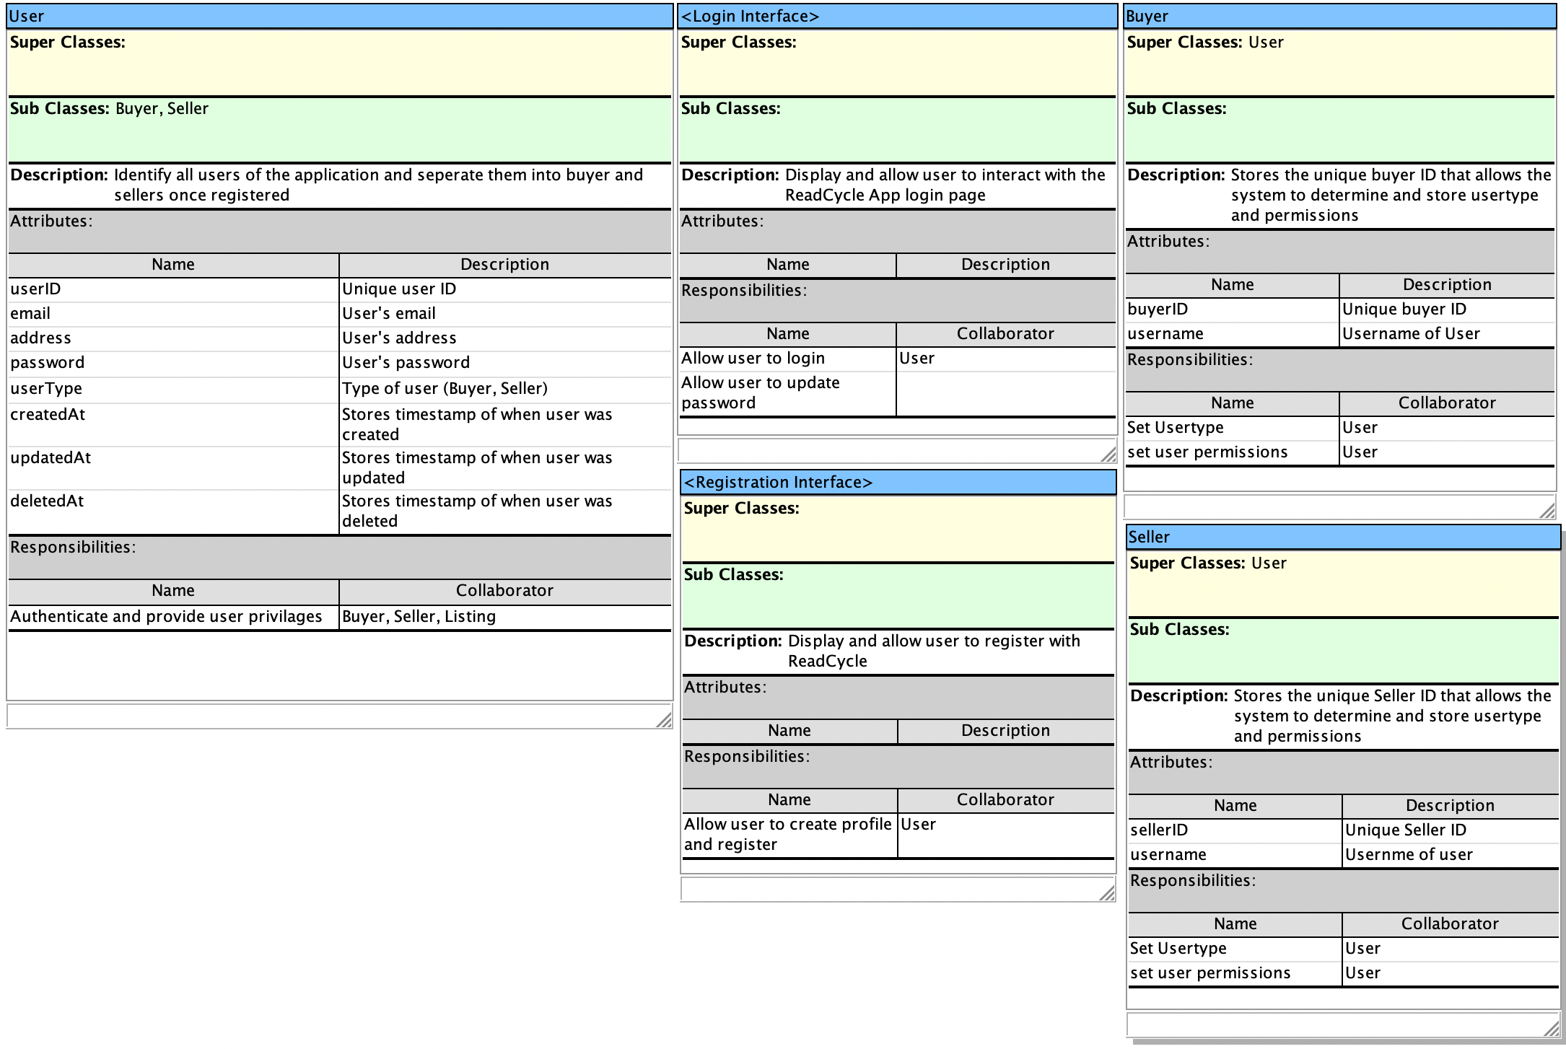

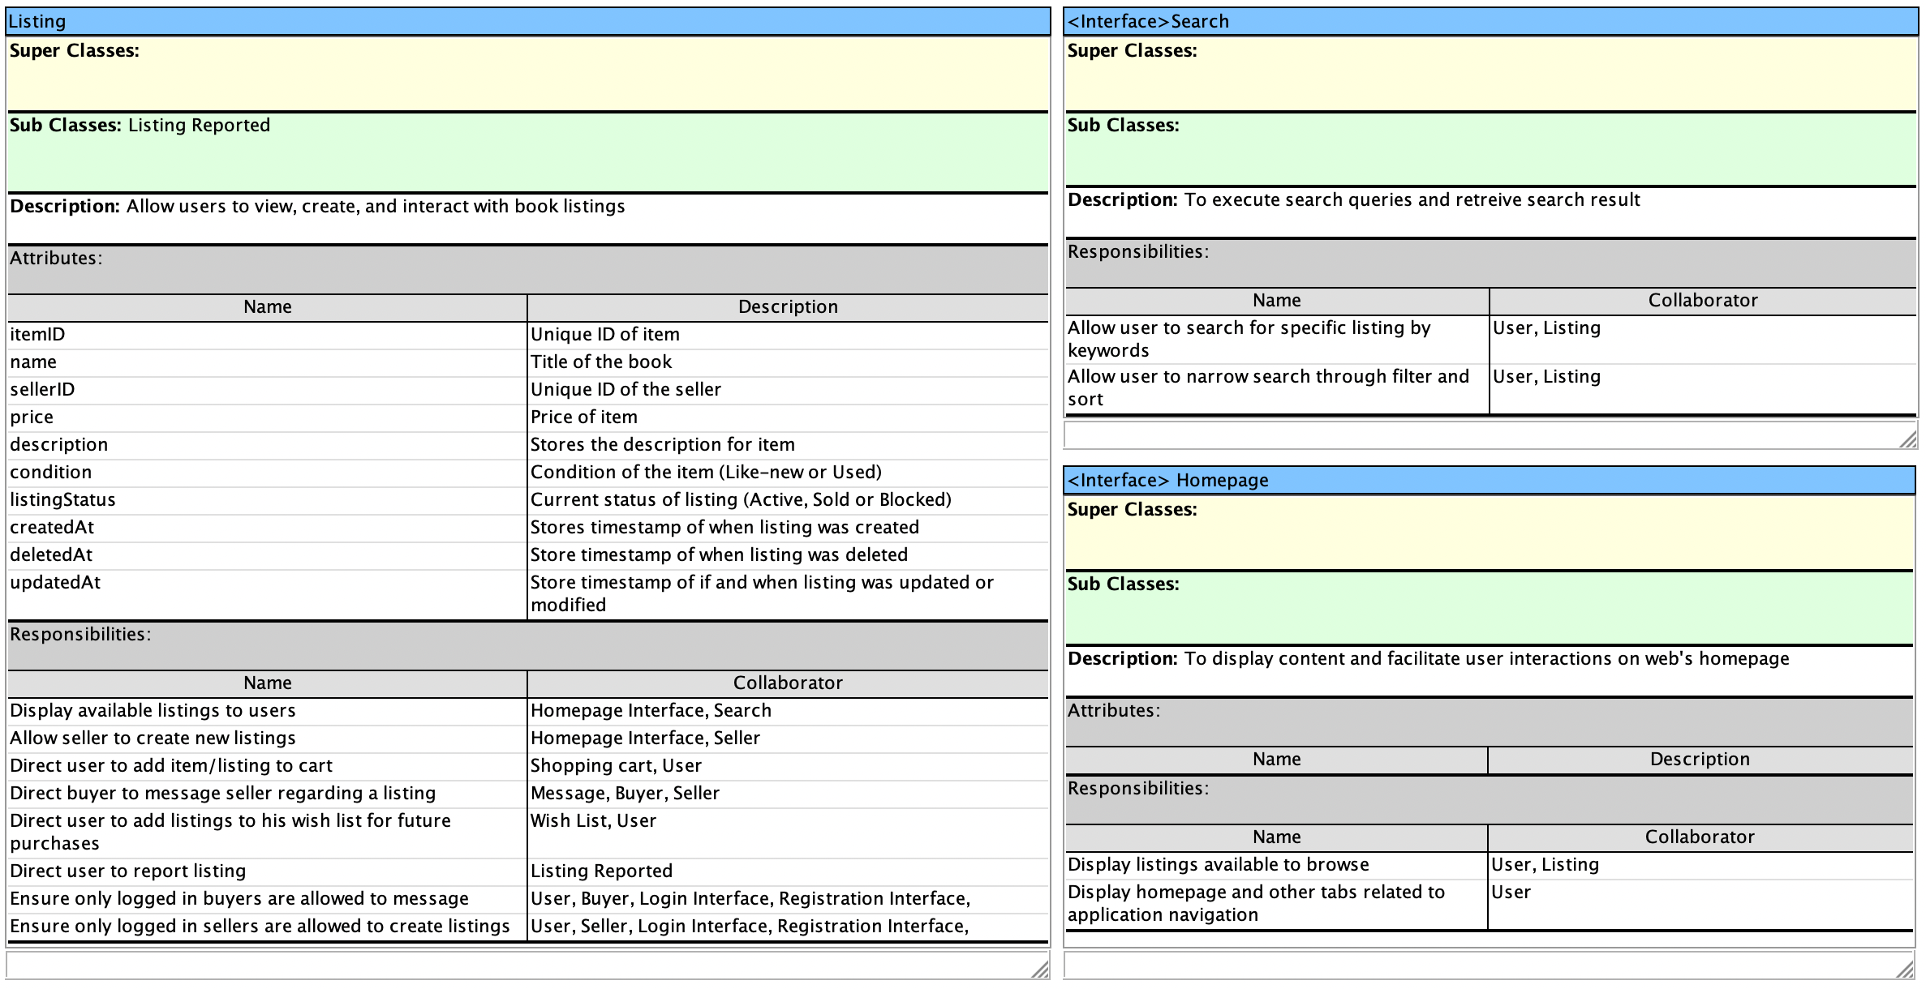

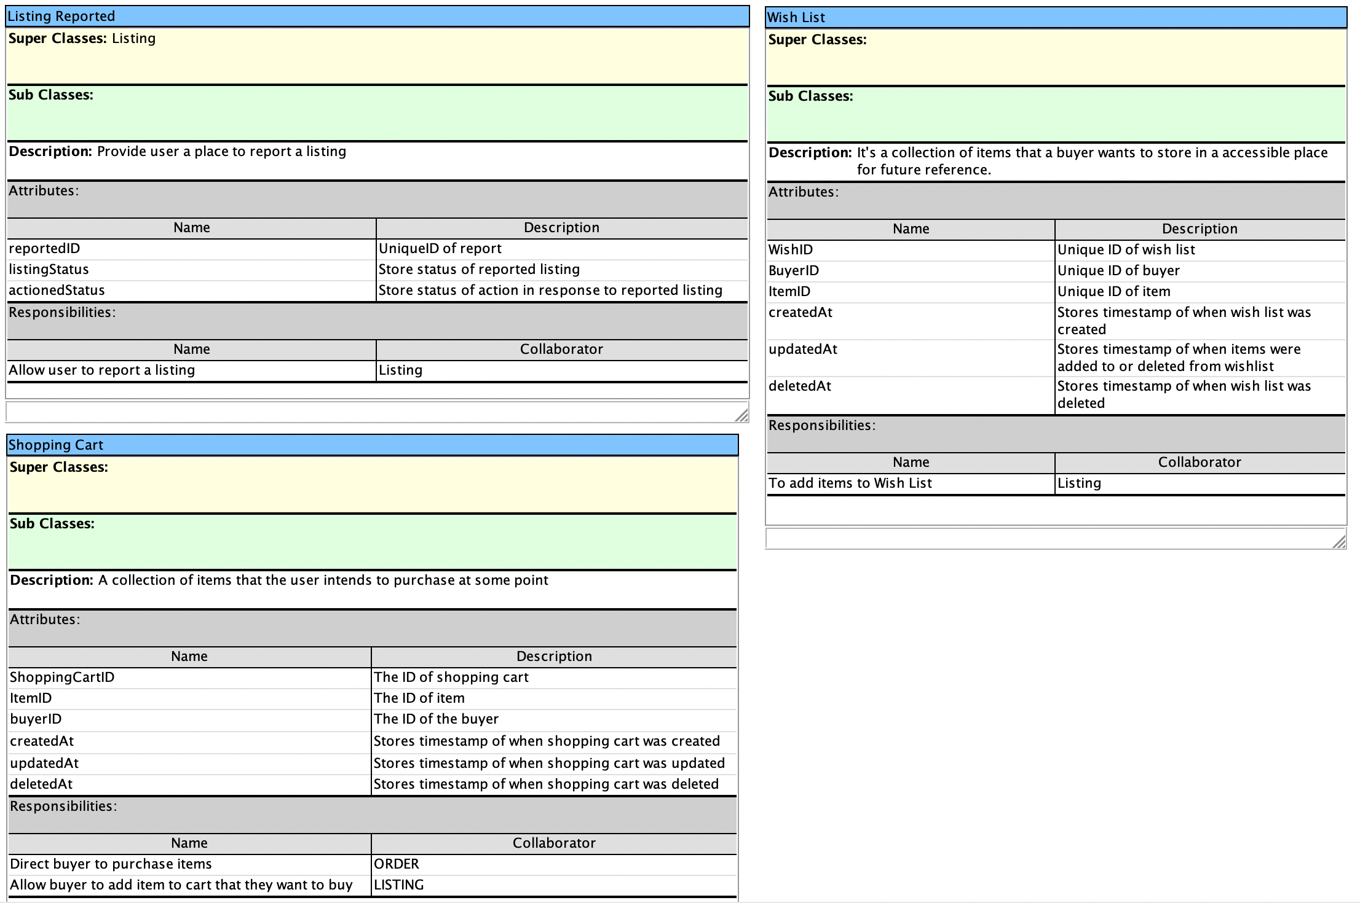

### 3.2.2 Payment Subsystem CRC

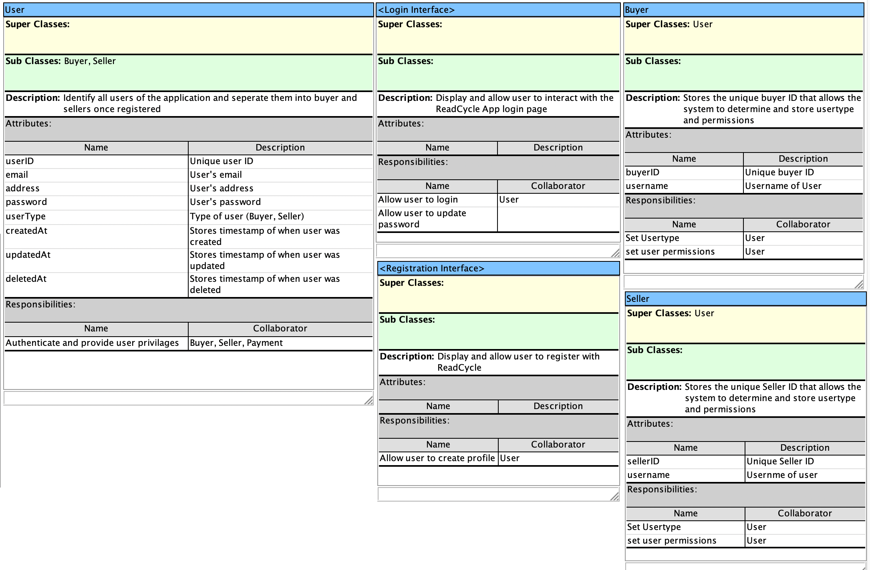

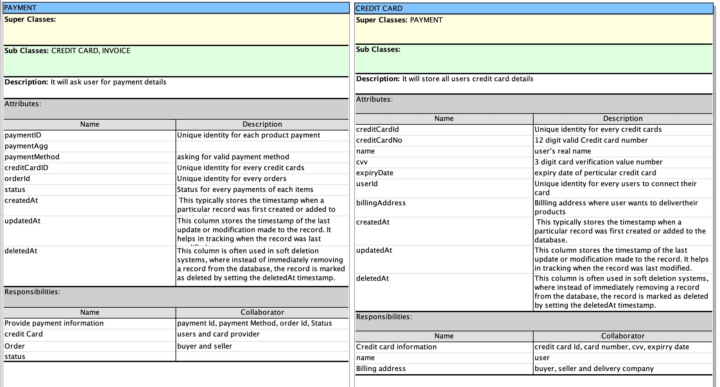

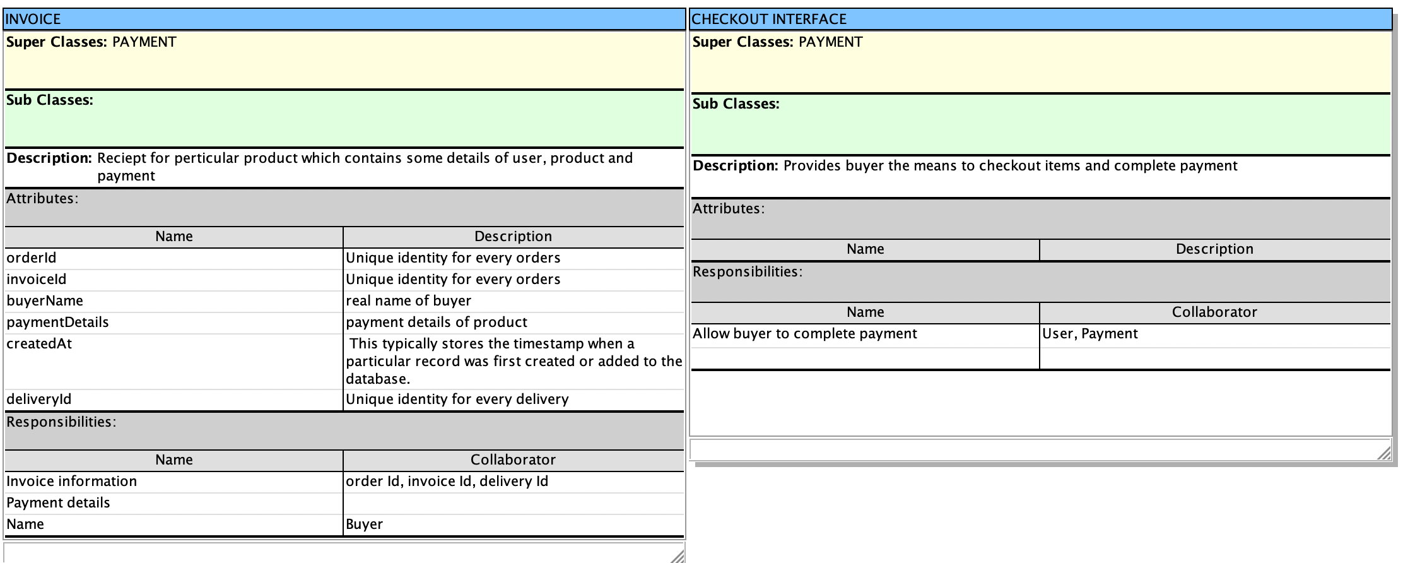

### 3.2.3 Messaging Subsystem CRC

## 

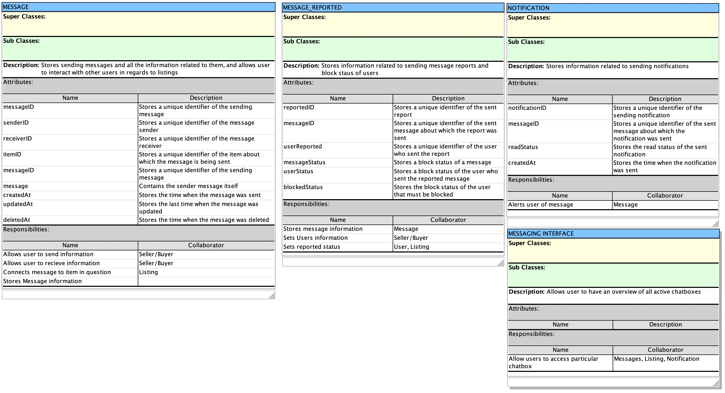

### 3.2.4 Order Subsystem CRC

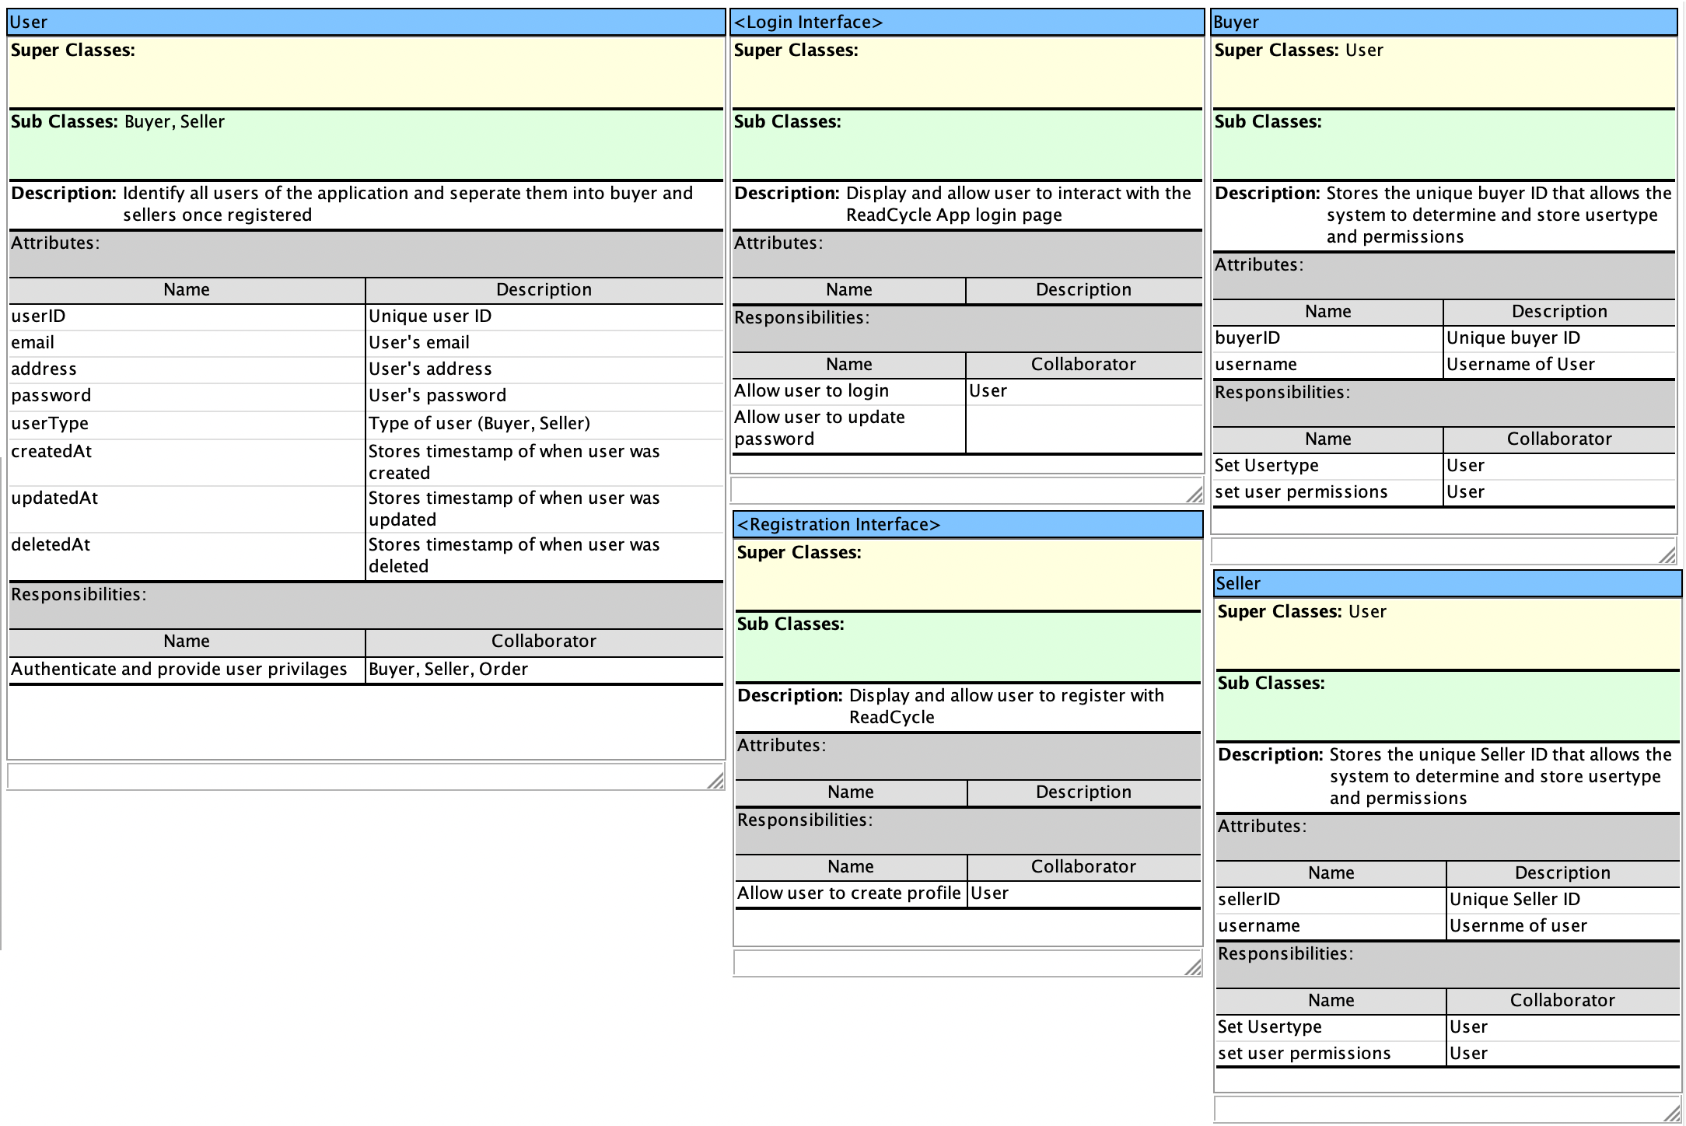

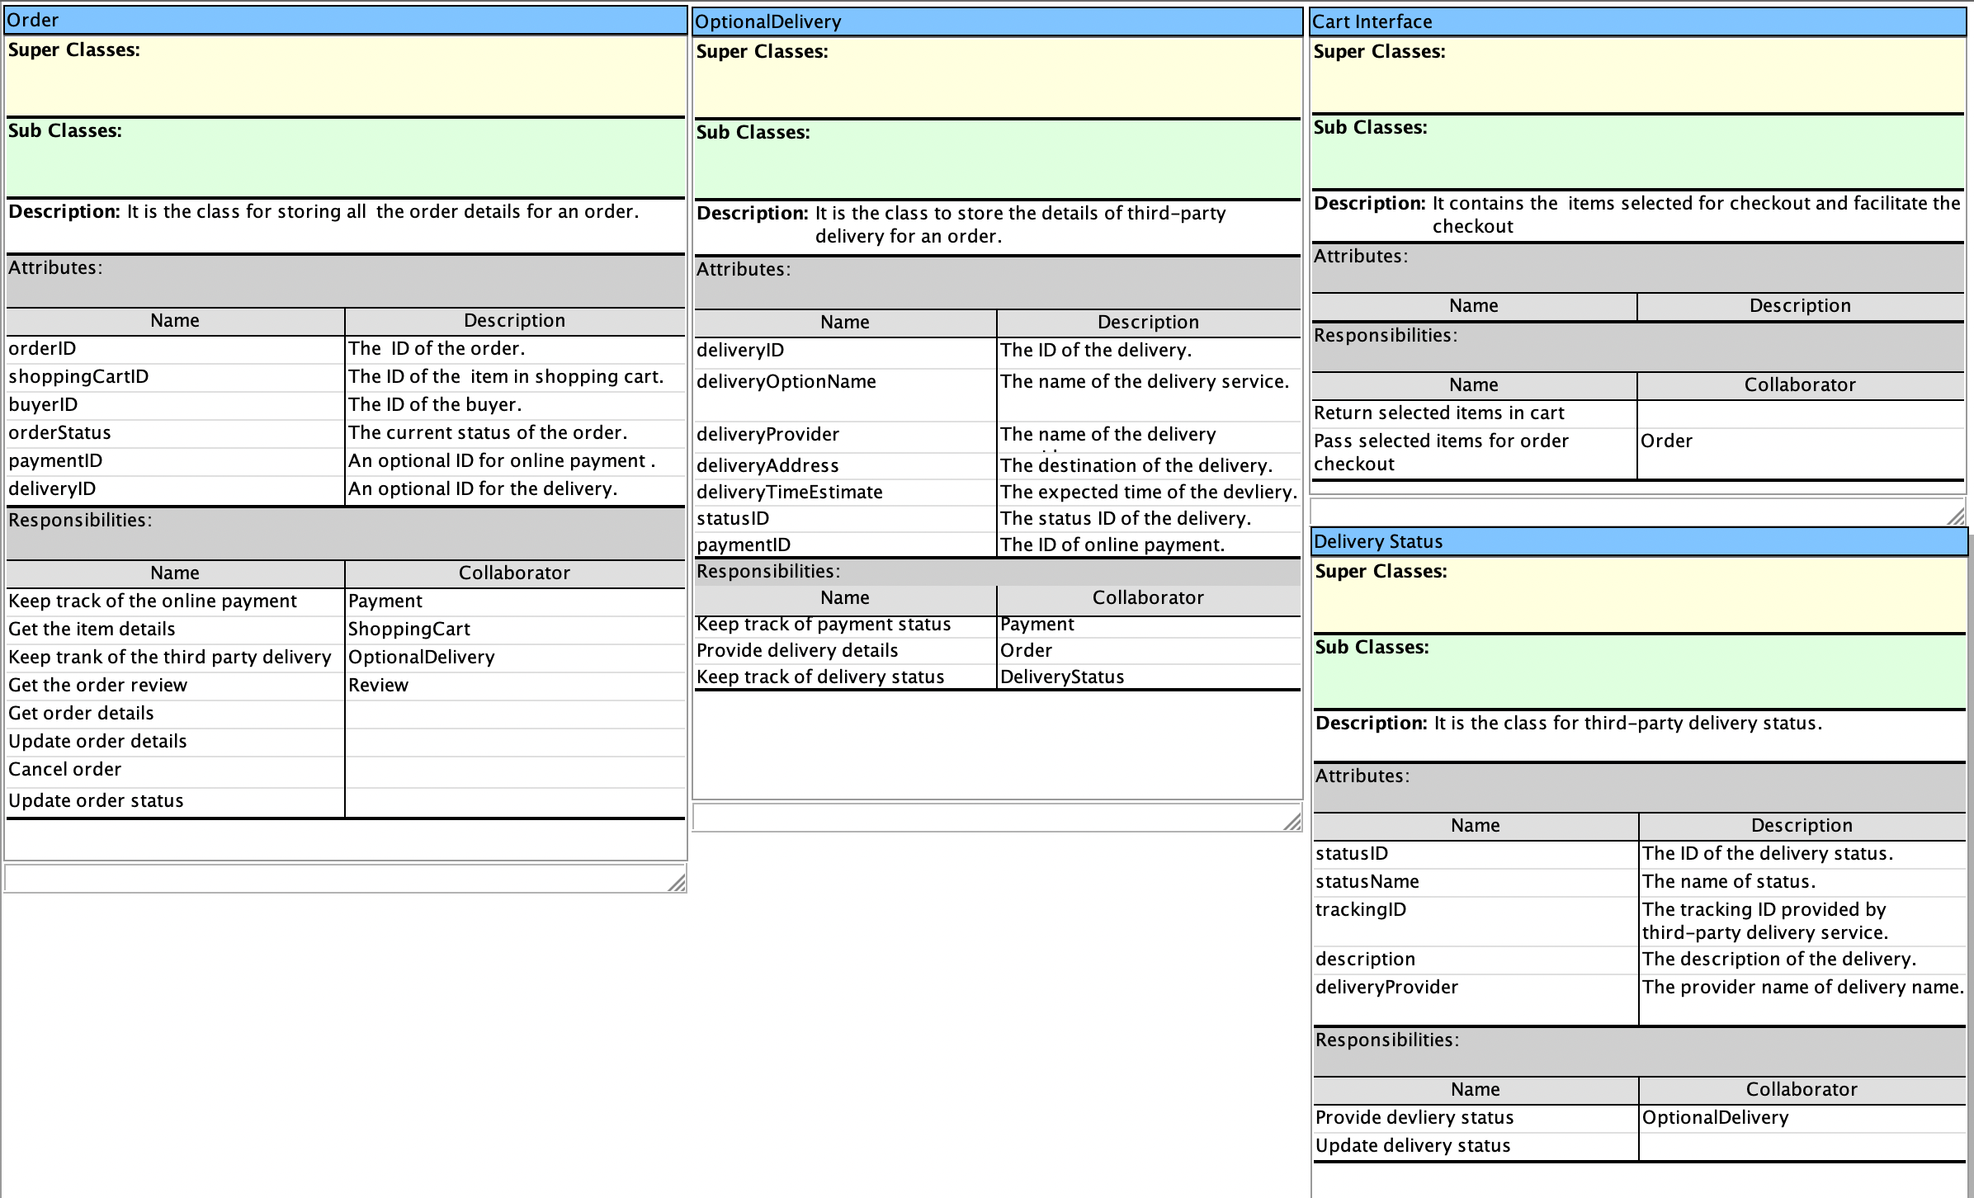

## 3.3 Design Classes Diagram

### 3.3.1 Listing Subsystem

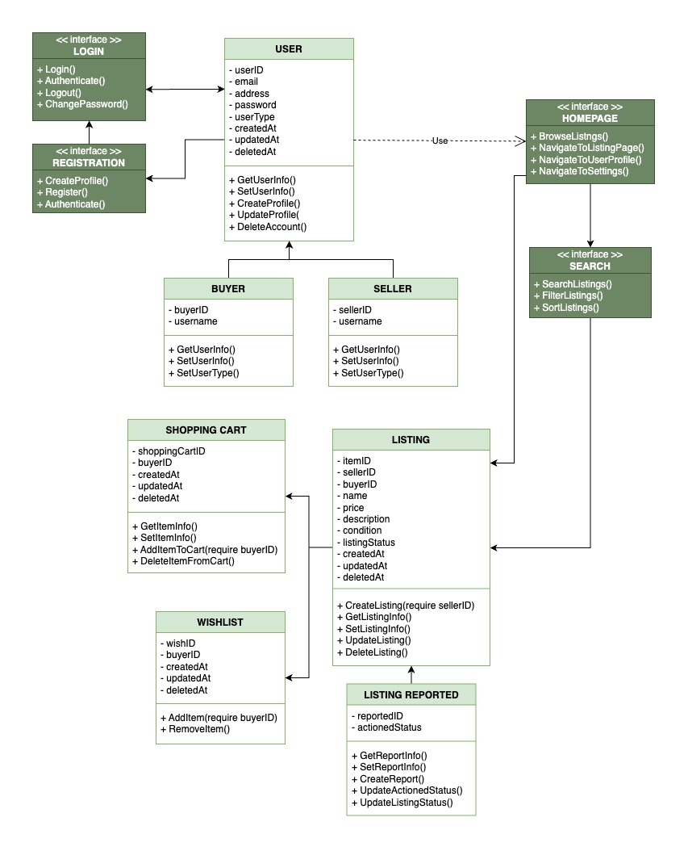

### 3.3.2 Payment Subsystem

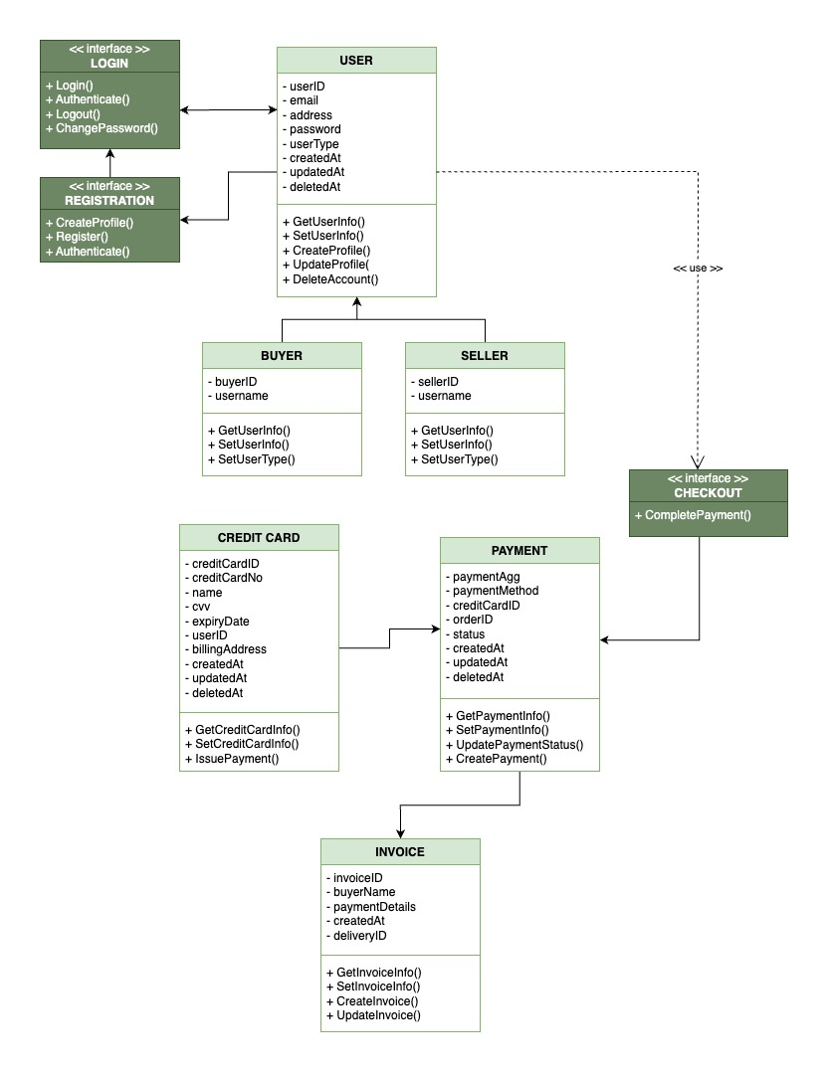

### 3.3.3 Messaging Subsystem

### 

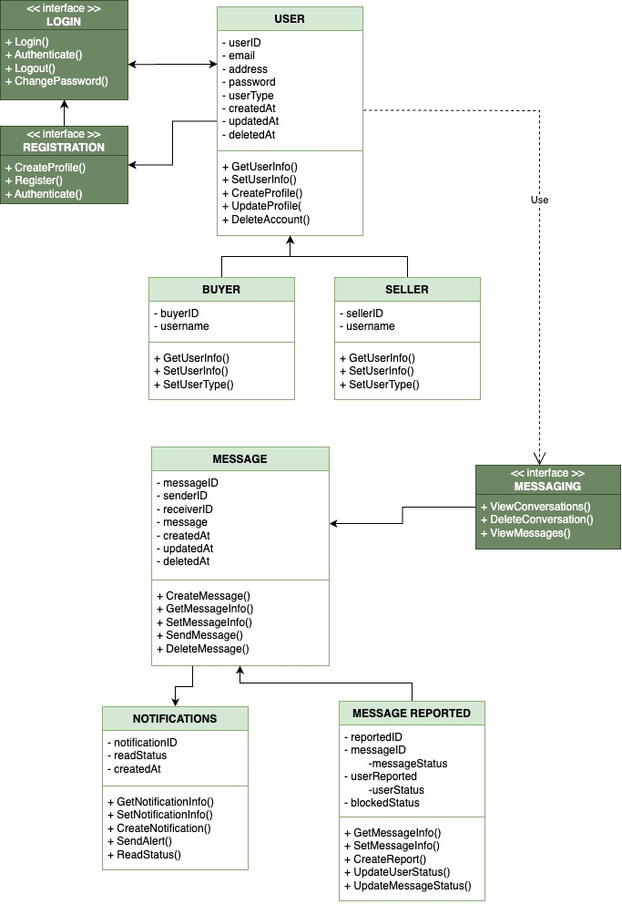

### 3.3.4 Order Subsystem

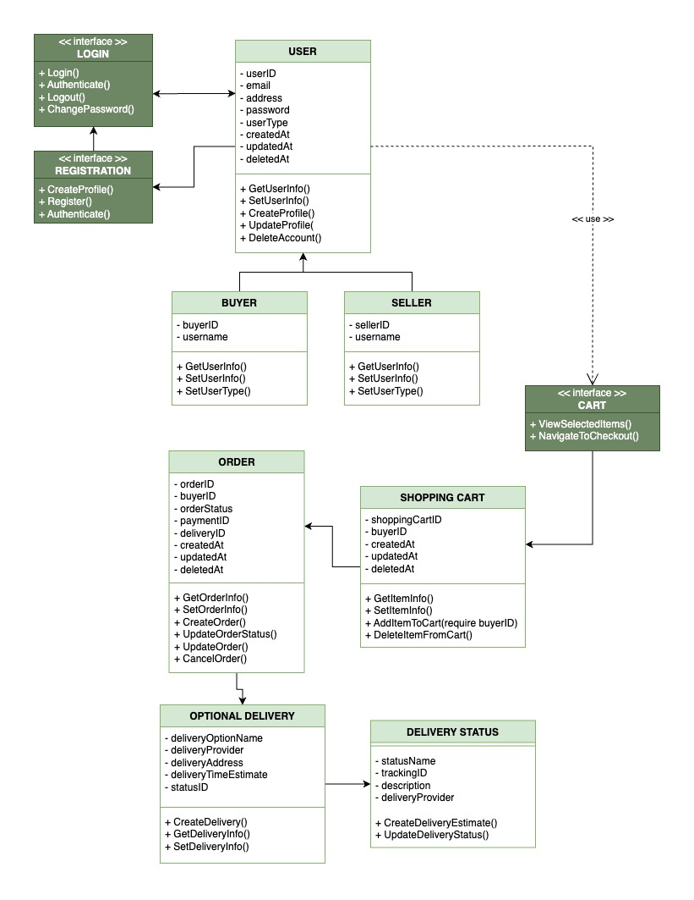

# SECTION IV Framework Model View Controller

## 4.1 MVC Diagrams

### 4.1.1 Listing Subsystems

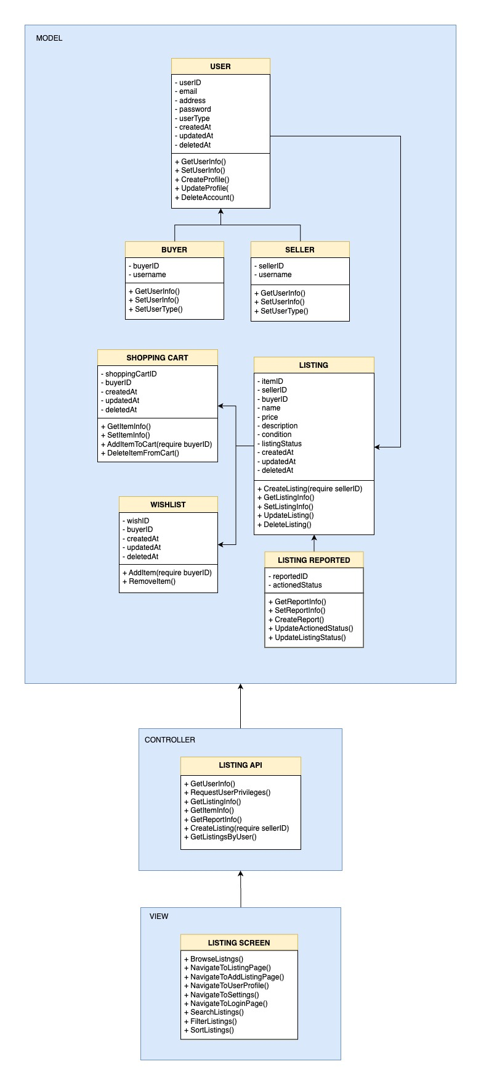

### 4.1.2 Payment Subsystems

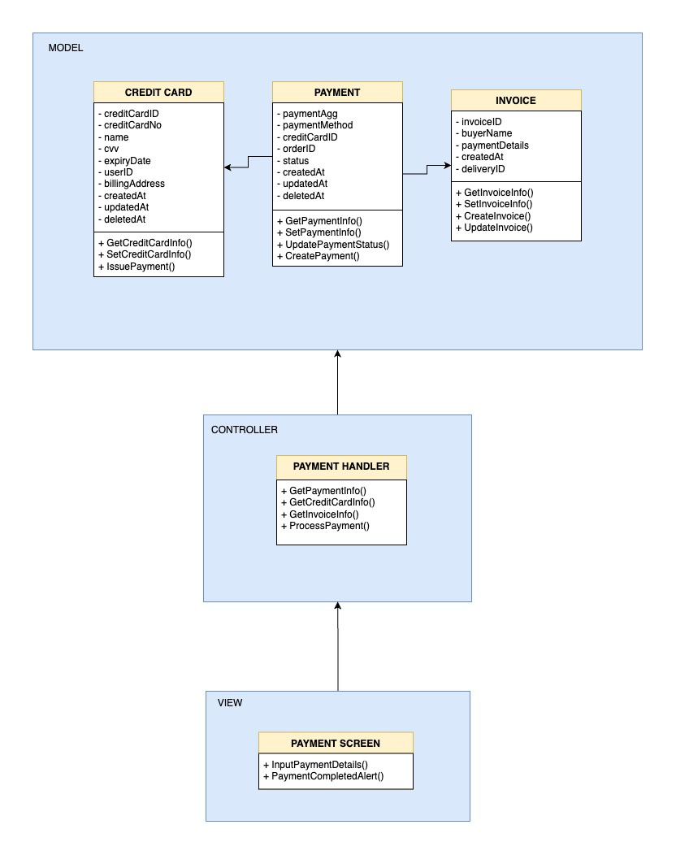

### 4.1.3 Messaging Subsystem

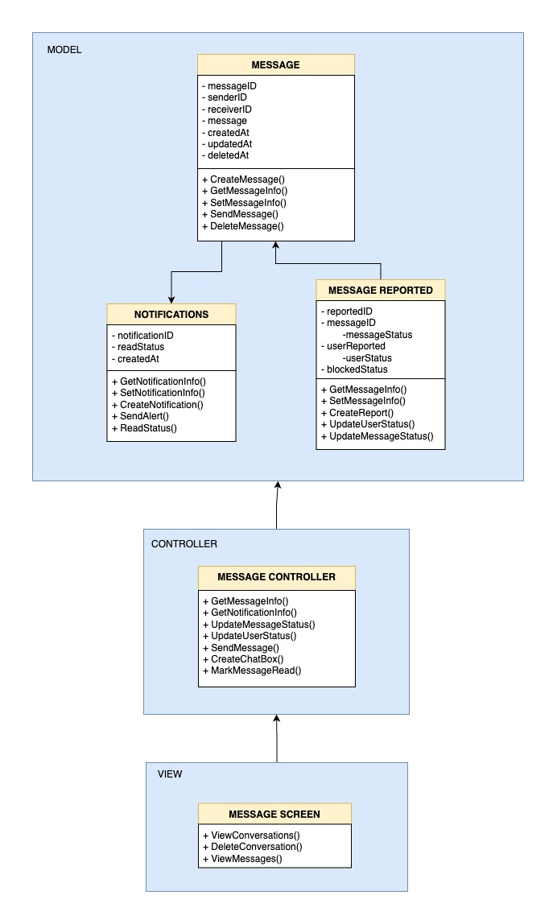

### 4.1.4 Order Subsystem

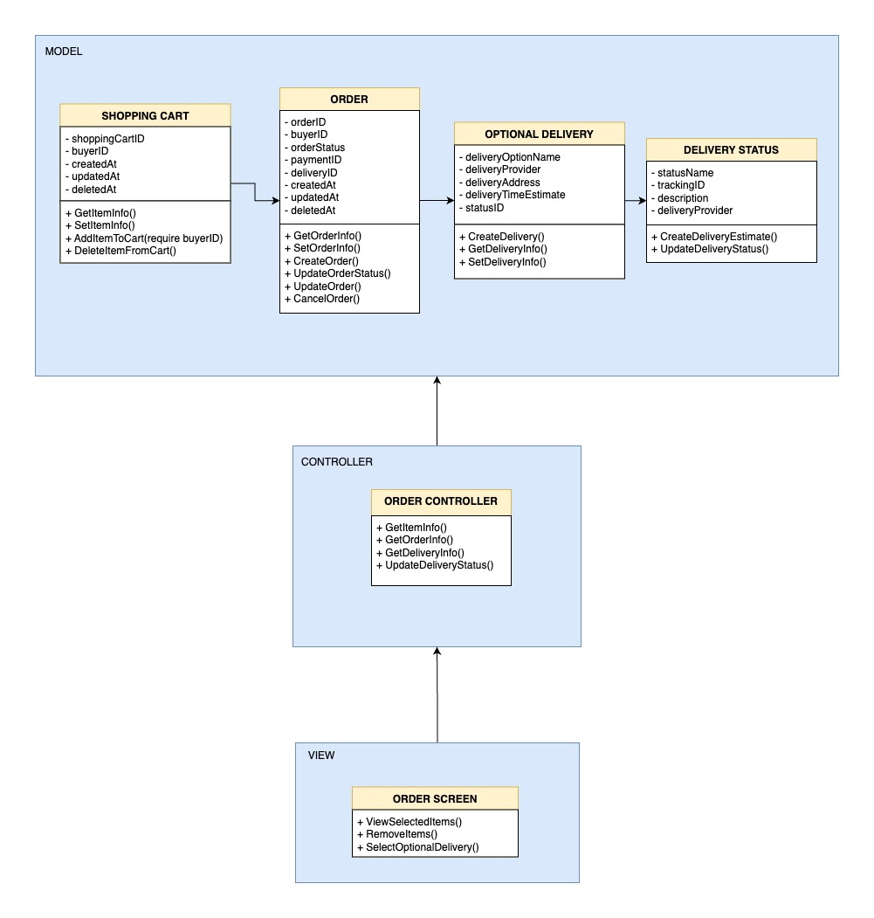

## 4.2 Full Sequence Diagrams

### 4.2.1 Sequence Diagram 1

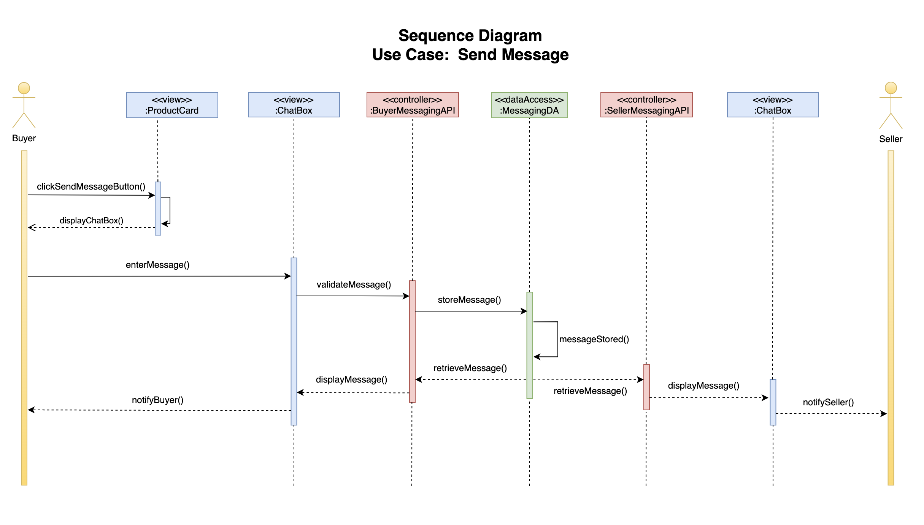

### 4.2.2 Sequence Diagram 2

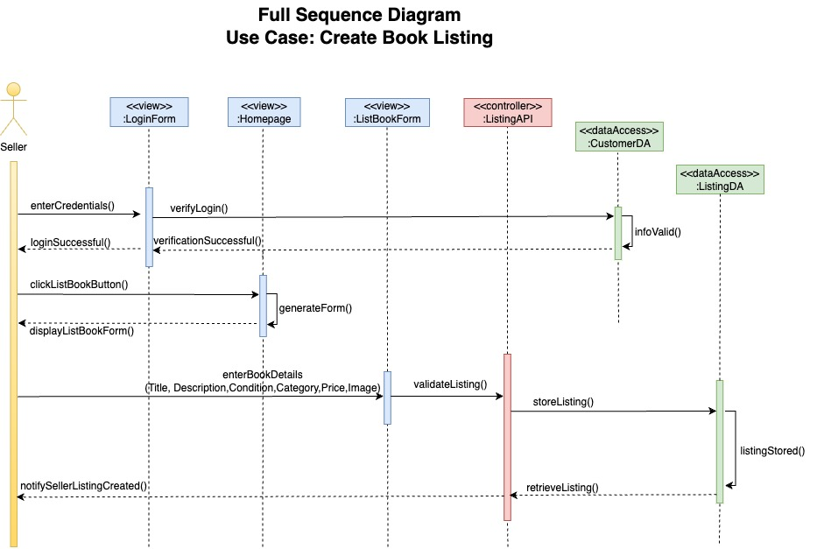

## 4.3 State Machine Diagrams

### 4.3.1 Listing State Diagram

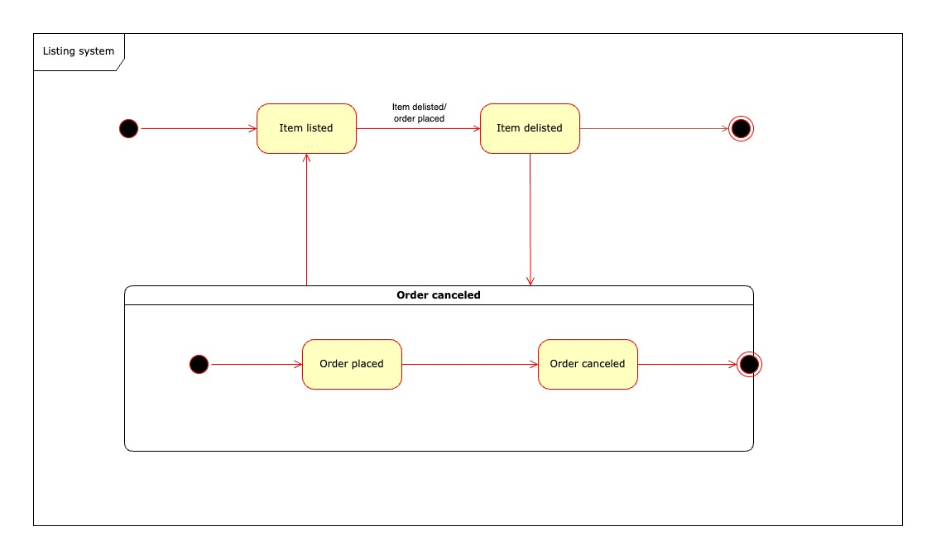

### 4.3.2 Order State Diagram

## 

# SECTION V Data Layer

## 5.1 Database Schema

## 5.2 Technology List Update

No updates required.

# SECTION VI Project Management

## 6.0 Updated Gantt Chart

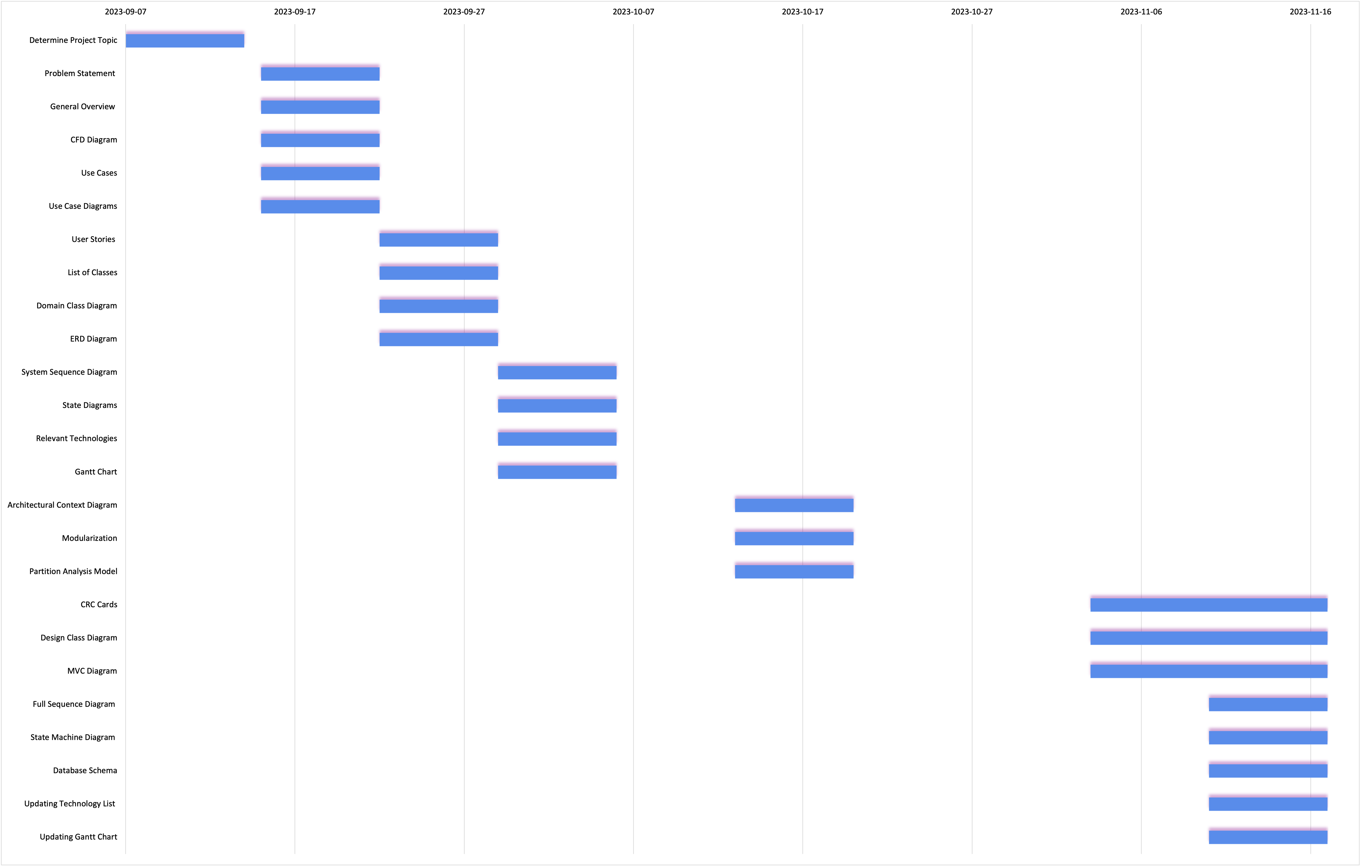

# **PART C**

# SECTION I.0 Corrections

## 1.0.1 Updated Sequence Diagram for Messaging Subsystem

* Changed the sequence diagram for messaging subsystem as requested in professor feedback

# SECTION I Software Design Patterns

**State Pattern**

* The State Pattern allows an object to alter its behavior when its internal state changes. It is particularly useful when an object transitions through different states, and its behavior needs to change dynamically based on its current state. In the context of managing the lifecycle of orders, the State Pattern can be beneficial to control the transitions between different order states and enforce specific rules associated with each state. This ensures that the order progresses correctly through its lifecycle.

**Adapter Pattern**

* The Adapter Pattern allows the interface of an existing class to be used as another interface, bridging the gap between incompatible interfaces. This pattern is beneficial when integrating new functionality or systems that have different interfaces. In your project, if there are external components or systems with interfaces that are incompatible with your order management system, the Adapter Pattern can be applied to make them work seamlessly together. It acts as a bridge, translating the interface of one system into an interface that your system expects.

**Façade Pattern**

* + The Facade Pattern provides a simplified and unified interface to a set of interfaces in a subsystem. It is used when there is a complex system with multiple components, and you want to provide a high-level interface to interact with the system without exposing its internal complexities. In your project, if there are complex interactions related to managing the lifecycle of orders, as mentioned in a previous scenario, a facade can be implemented to simplify the order status transitions and shield users from intricate details.

# SECTION II Using Common Software Design Patterns

## 2.1 Listing

|  |  |
| --- | --- |
| **Name** | **Listing Subsystem** |
| **Problem** | The current listing subsystem faces challenges related to ineffective state management. Instances include inconsistencies in updating the listingStatus when a listing is modified or deleted, leading to potential errors and a lack of clarity regarding the lifecycle of listings. These issues compromise data integrity and impede the seamless operation of the listing subsystem. |
| **Solution** | To address the problem of ineffective state management, the listing subsystem will incorporate the State Pattern. This behavioral design pattern will provide a structured approach by encapsulating distinct states (e.g., "Active," "Inactive," "Deleted") in separate classes. The dynamic switching between states ensures consistent state changes and robust management of listing behaviors. |
| **Graph** |  |
| **Benefits and Consequences** | **Benefits:**   * **Consistent State Changes:** The State Pattern guarantees uniform handling of state changes, mitigating errors and maintaining data integrity. * **Scalability:** Adaptable to new states or adjustments to existing ones, enhancing the listing subsystem's flexibility and ease of maintenance. * **Improved Maintenance:** Despite initial complexity, the State Pattern often results in enhanced code maintainability and extensibility over time.   **Consequences:**   * **Complexity:** Introducing the State Pattern may add intricacy to the codebase, especially if there are numerous states and transitions. * **User Training:** Users may require minimal training to comprehend the updated state management system within the listing subsystem. |

## 2.2 Payment

|  |  |
| --- | --- |
| **Name** | **Payment Subsystem** |
| **Problem** | The current payment subsystem in the book marketplace software faces significant challenges, hindering user trust, efficient payment gateway integration, reliable transactions, fraud prevention, regulatory compliance, refund and dispute resolution, scalability, optimal user experience, support for cross-border transactions, seamless integration with the book inventory system, and efficient notifications. Users express concerns regarding the security of their financial data, limited payment methods, susceptibility to fraud, and unclear transaction processes. |
| **Solution** | To overcome the identified challenges, the proposed solution strategically leverages the Adapter pattern. By integrating a trusted external payment service, akin to the Adapter pattern's philosophy, the book marketplace software adapts to proven technologies and best practices without the need to build the payment subsystem entirely from scratch. This external payment service serves as an adapter, acting as a bridge between the book marketplace software's interface and the external payment system. The Adapter pattern ensures seamless communication, compatibility, and the ability to flexibly adapt to changes in payment methods or providers while minimizing impact on the core logic of the software. |
| **Graph** |  |
| **Benefits and Consequences** | **Benefit:**   * A secure and reliable payment subsystem instills confidence in users, encouraging them to make transactions on the platform. * Advanced fraud detection measures protect both users and the platform from unauthorized transactions, maintaining the integrity of the marketplace. * A scalable payment subsystem accommodates the growing number of transactions, supporting the platform's expansion. * Support for cross-border transactions expands the marketplace's reach, attracting a diverse user base. * A well-functioning payment subsystem contributes to the financial stability of the platform through transaction revenue.   **Consequence:**   * Inadequate security measures may result in a lack of user trust, leading to a decrease in transactions and user engagement. * Failure to address fraud risks can lead to financial losses, damage to the platform's reputation, and legal consequences. * Lack of scalability may lead to system crashes, slow performance, and an inability to handle increased transaction volumes during peak periods. * Neglecting international considerations may limit market growth and alienate potential users in different regions. * Payment failures or disputes can impact revenue streams, hindering the platform's financial health. |

## 2.3 Messaging

|  |  |
| --- | --- |
| **Name** | **Messaging Subsystem** |
| **Problem** | The messaging subsystem currently suffers from redundancies that pose potential inconsistencies and maintenance challenges. Specifically, the **MESSAGE** and **MESSAGE REPORTED** classes duplicate the methods **GetMessageInfo()** and **SetMessageInfo()**, introducing complexities and potential errors during modifications. Furthermore, the **MESSAGE REPORTED** class features an unnecessary **userStatus** attribute, duplicating the functionality of the existing **blockedStatus** attribute within the same class. These redundancies hinder the clarity and efficiency of the codebase, impacting both readability and maintainability. |
| **Solution** | To systematically address the identified redundancies and enhance the messaging subsystem, an effective refactoring pattern solution is proposed, integrating the Decorator pattern. Specifically, the redundant methods (**GetMessageInfo()** and **SetMessageInfo()**) present in both the **MESSAGE** and **MESSAGE REPORTED** classes are eliminated. Additionally, the unnecessary **userStatus** attribute in the **NOTIFICATION** class, which duplicates the functionality of the **blockedStatus** attribute, is removed. The Decorator pattern is employed to dynamically extend the behavior of these classes without modifying their structure, ensuring a streamlined and cohesive design. |
| **Graph** |  |
| **Benefits and Consequences** | **Benefits:**   * **Redundancy Elimination:** The integration of the Decorator pattern results in the systematic removal of redundant methods and attributes, promoting a cleaner and more efficient codebase.   **Consequences:**   * **Improved Readability:** The elimination of redundancies enhances code clarity, making it easier to read and understand. * **Simplified Maintenance:** With streamlined class structures, maintaining the code becomes more straightforward, reducing the likelihood of errors during modifications. |

## 2.4 Order

|  |  |
| --- | --- |
| **Name** | **Order Subsystem** |
| **Problem** | Since the users are going to place orders on their purchase of secondhand items they saw on the website, we need to manage the lifecycle of their orders and make sure the orders progress correctly. |
| **Solution** | To make sure the order status is managed correctly, we must code specific rules in application to limit the transition of order state, i.e., state A can only be transited to state B if it is allowed. To protect the order date integrity from concurrent modification, we must use transaction in database too. However, it would be difficult for users of the order system to understand the order transition rules and implement the database transaction outside of it. A façade will be provided to users of the order system to help them transit the order status and handle the concurrent requests. |
| **Graph** |  |
| **Benefits and Consequences** | **Benefits:**   * Data integrity – the data integrity is protected, and we would not have order in abnormal state. * Less race competition – there would not be two concurrent requests competing for the same data causing system error.   **Consequences:**   * Frequent code update– every time there is a breaking change on the façade, the users will have to update their code. * Slower processing time – with extra rule checking and database transaction for data modification, the total time required for each request increases. |

# SECTION III UI/UX Design

## 3.1 Listing

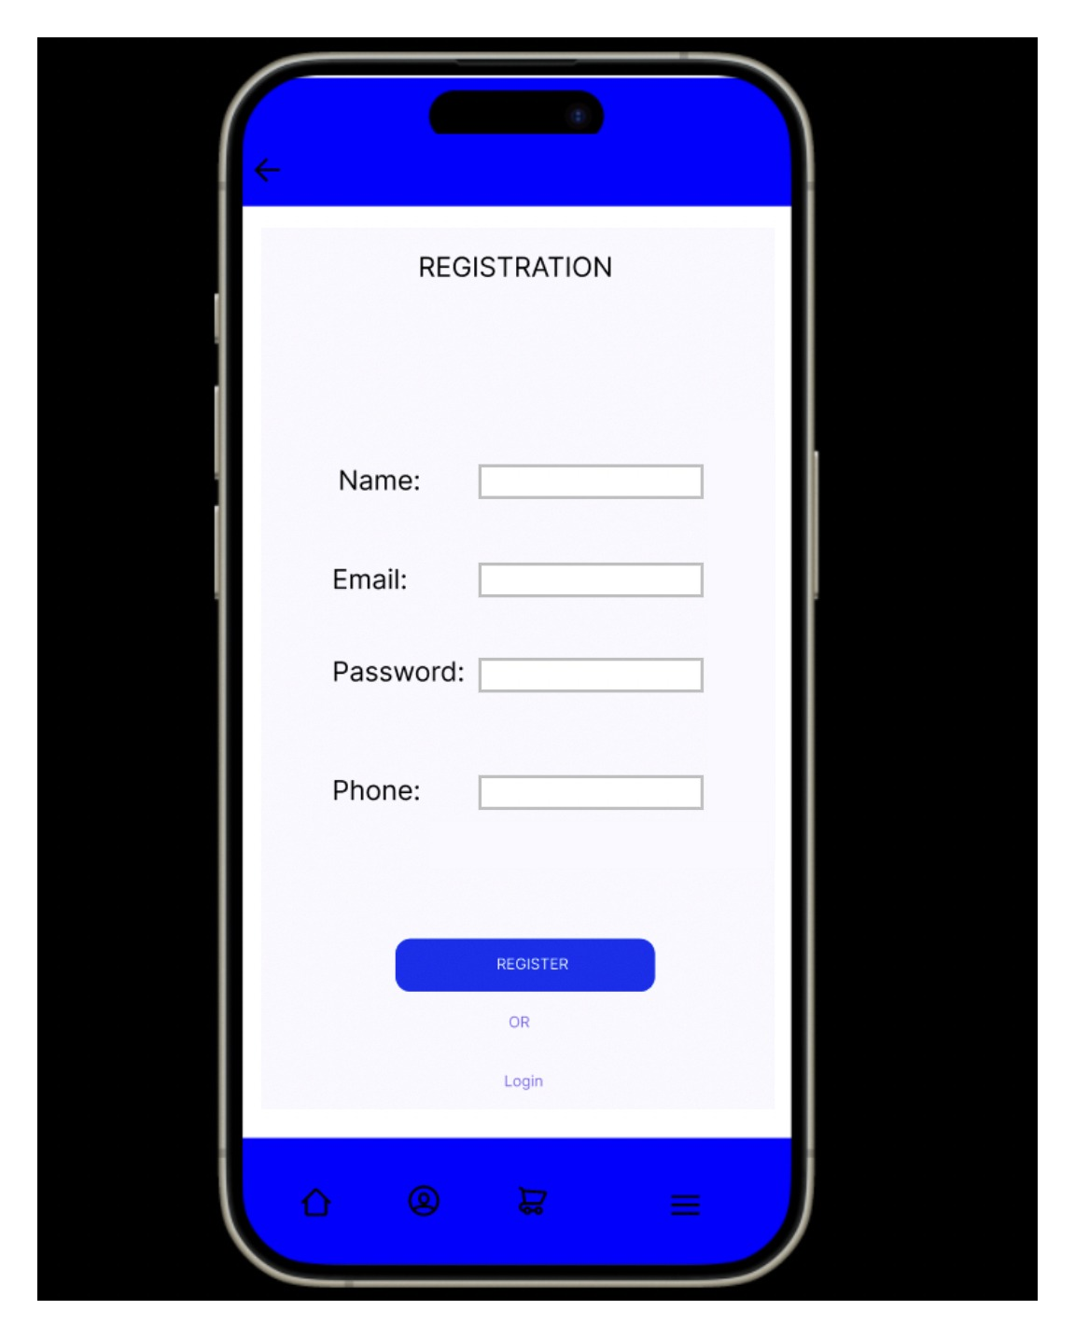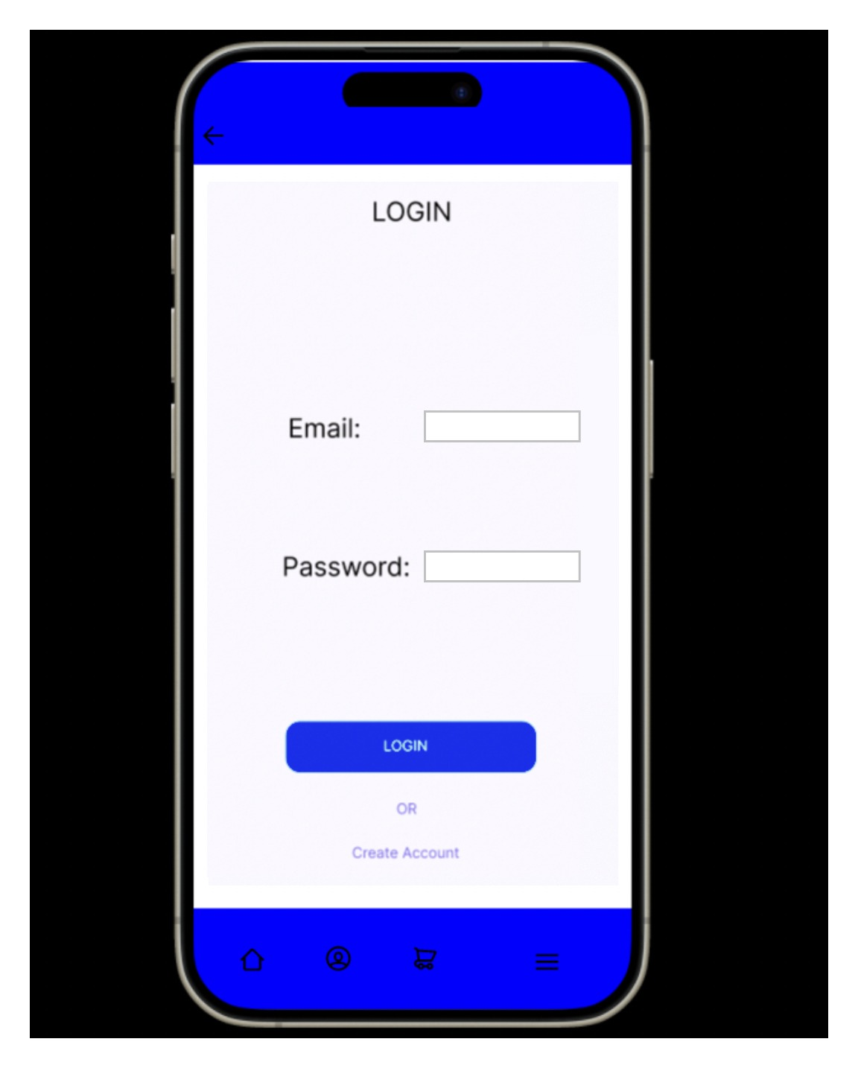 .

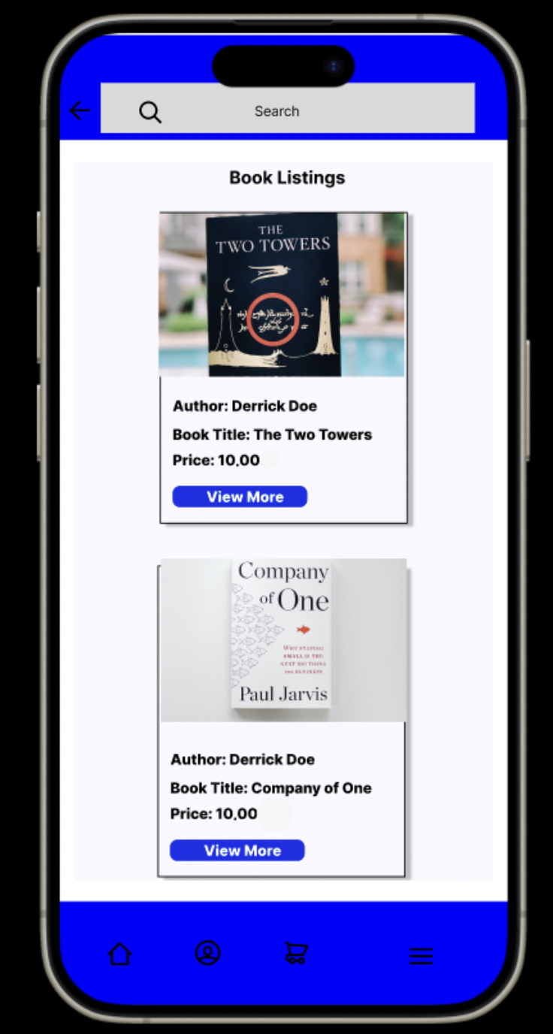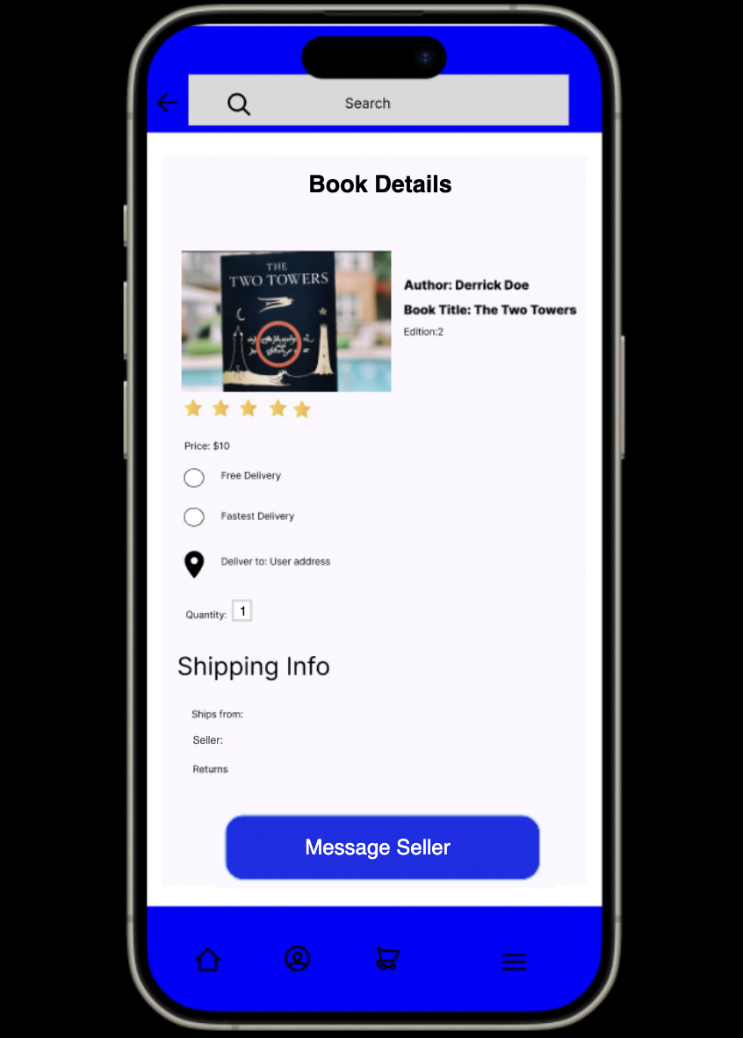

## 3.2 Messaging

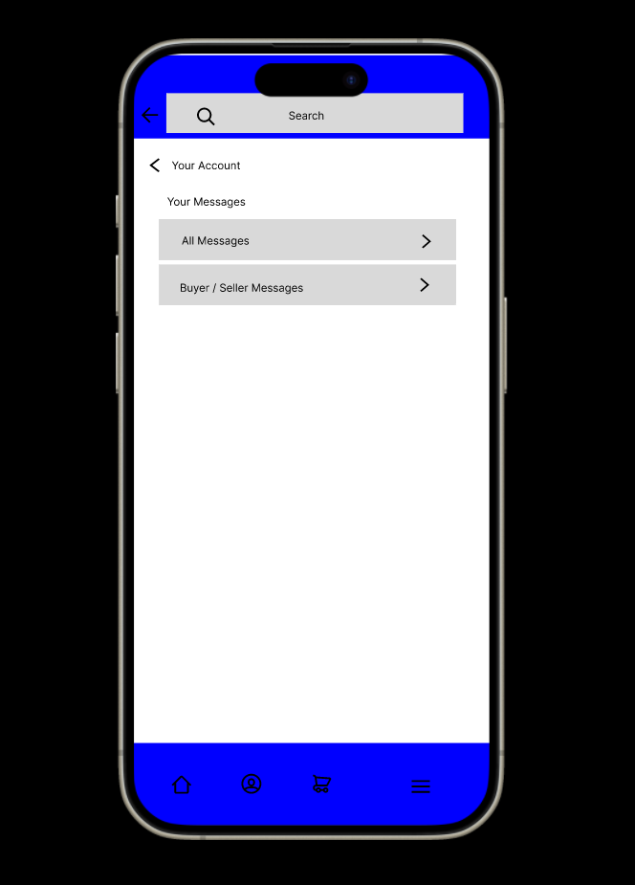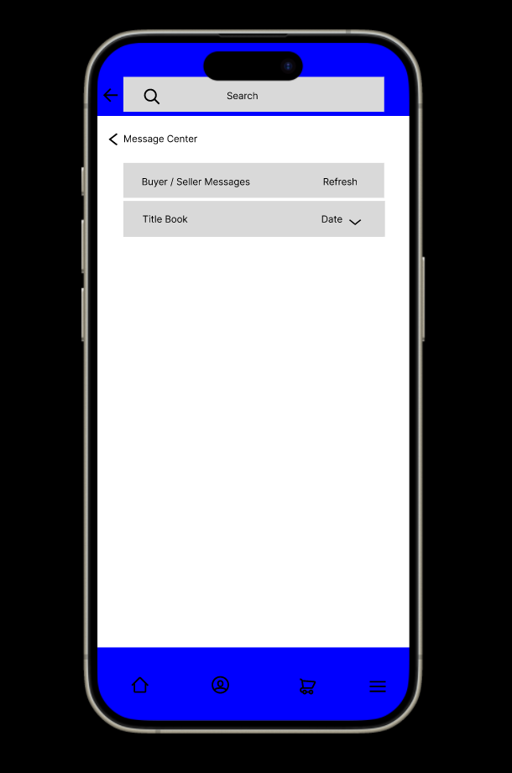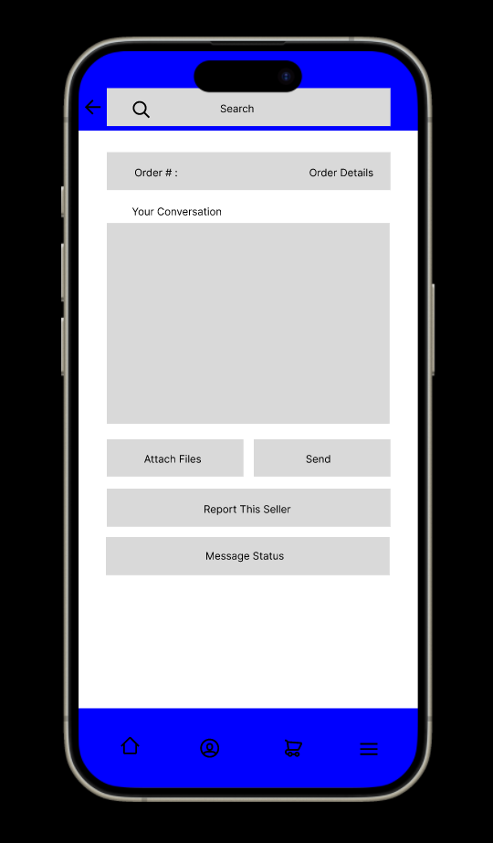

## 3.3 Order

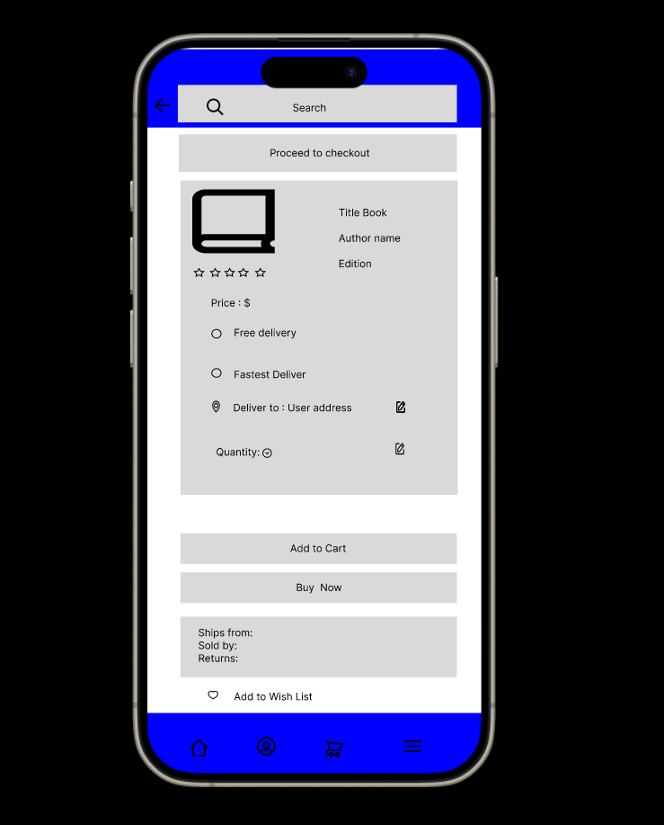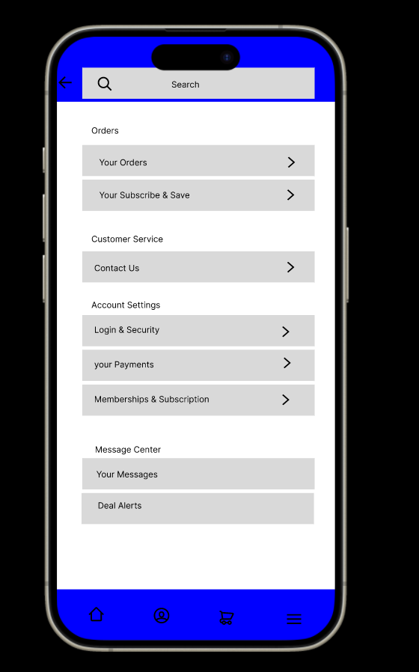

## 3.4 Payment

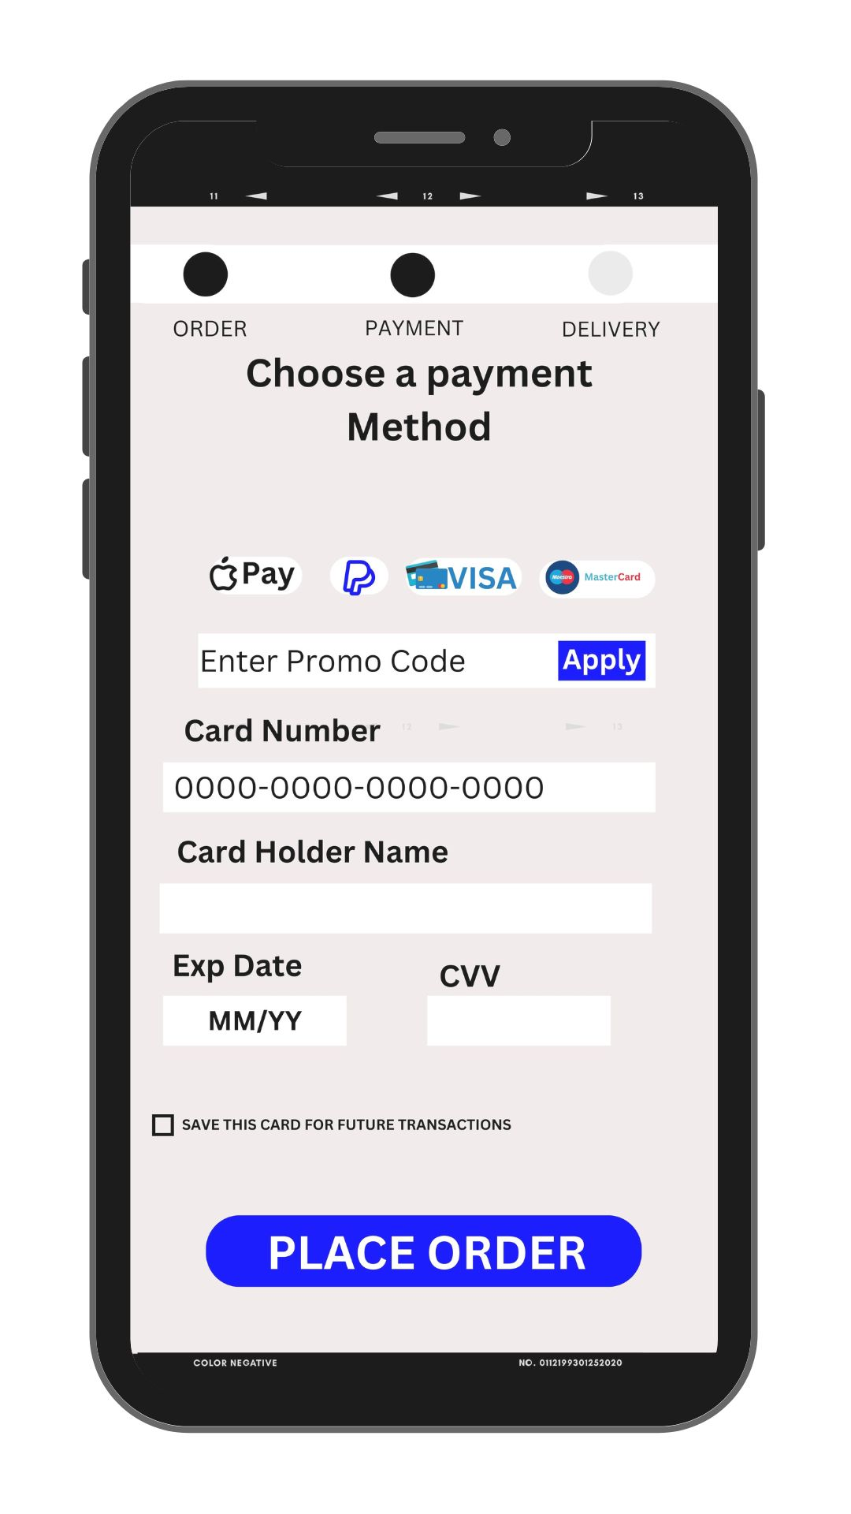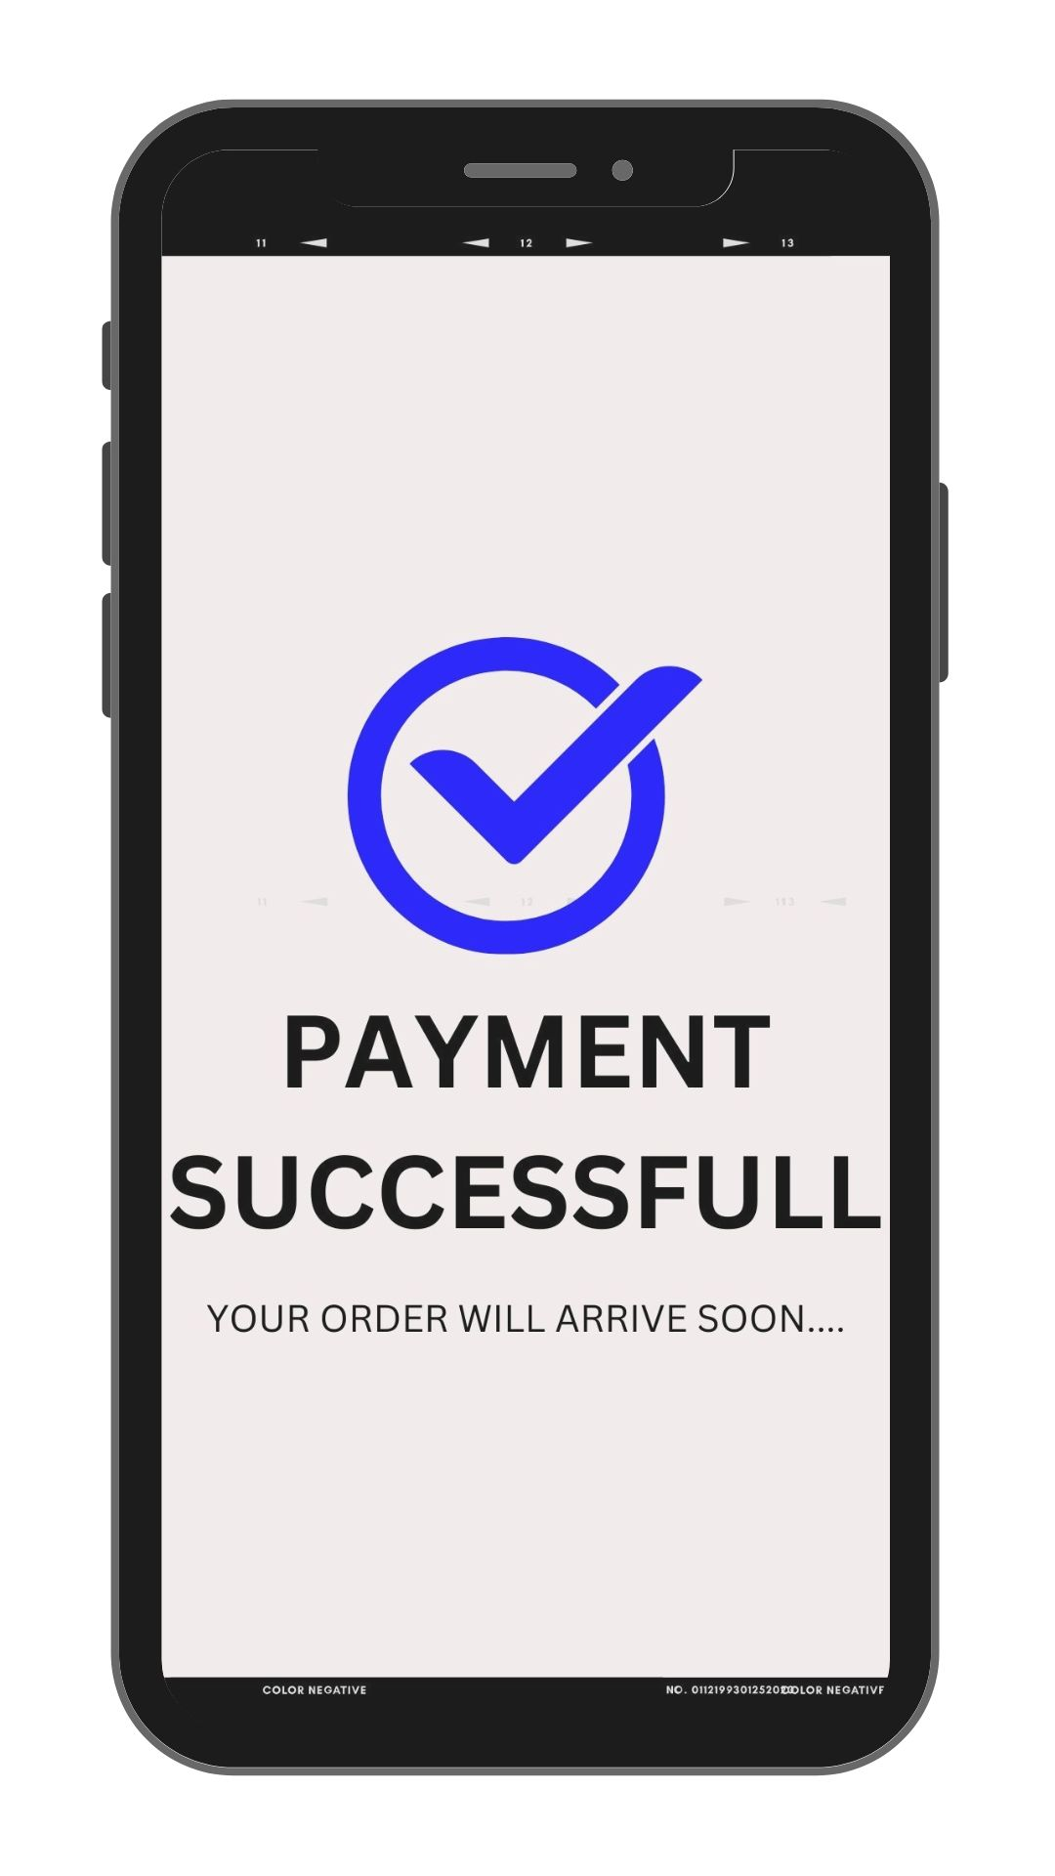

# SECTION IV High Level Component/Deployment Diagram

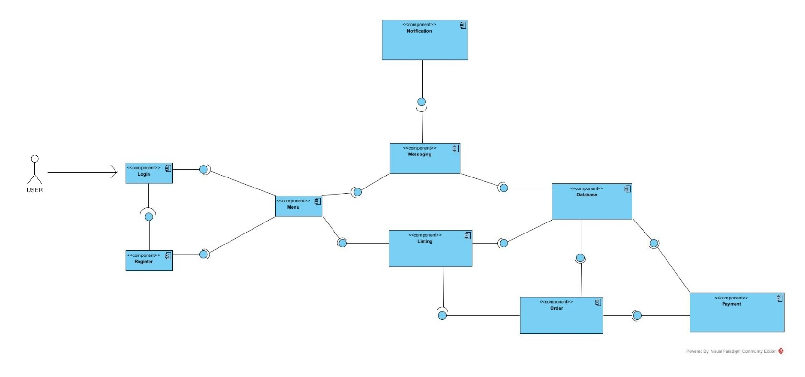

# SECTION V Project Management

